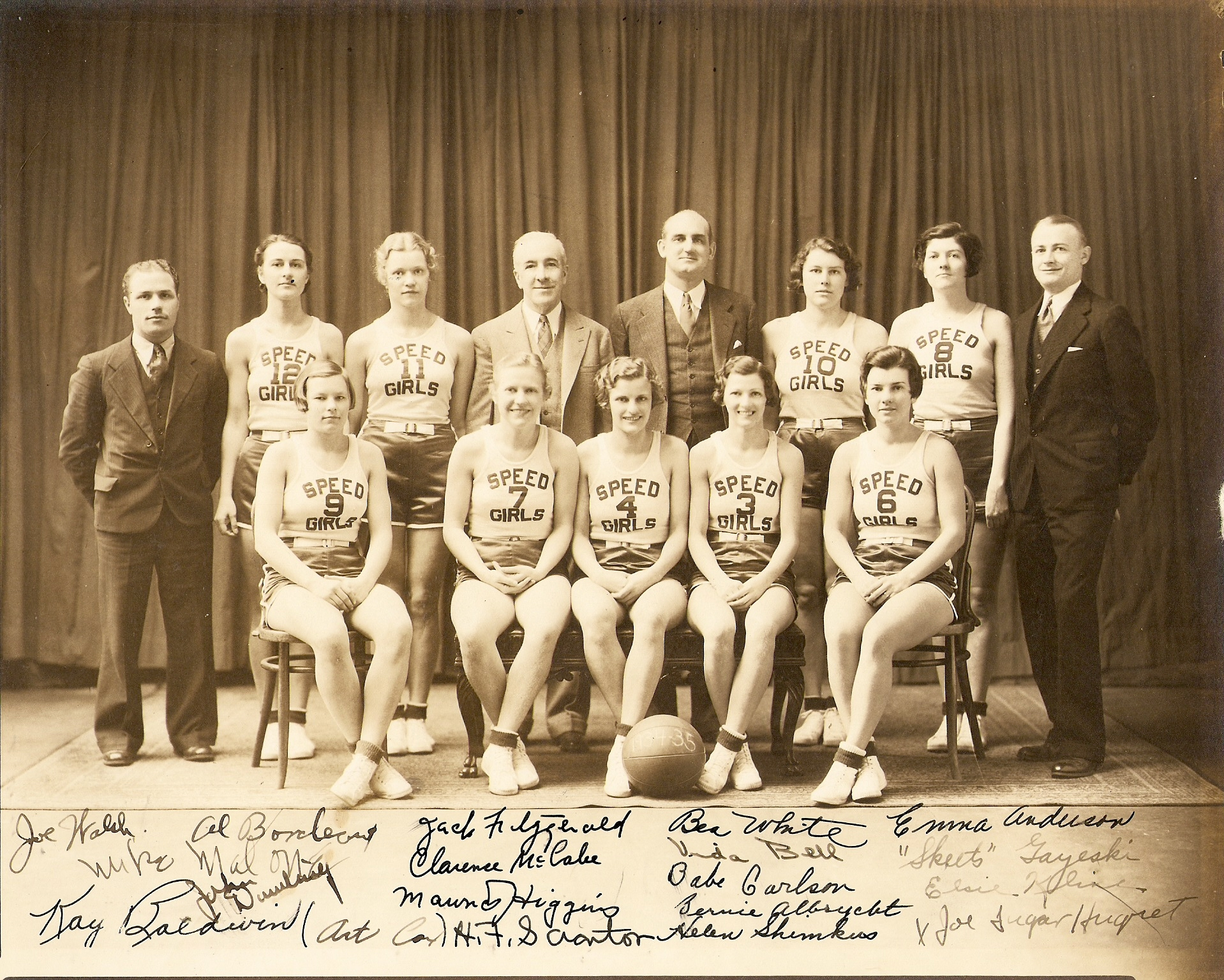
The 1934 -1935 team picture shows, seated from left to right: Helen (Babe)
Carlson (#9), Emma Anderson (#7), Captain “Skeets” Gayeski (#4), Bea
White (#3), and Elsie Kline (#6).
Standing left to right: unknown man, Bernice Albrycht (#12), Helen
Shimkus (#11), Jack Fitzgerald (owner/manager), Clarence “Mac”
McCabe (coach), Vida Bell (#10), Catherine (Kay) Baldwin (#8), and
Maurice Higgins (assistant manager).

Skeets Gayeski and the Speedgirls
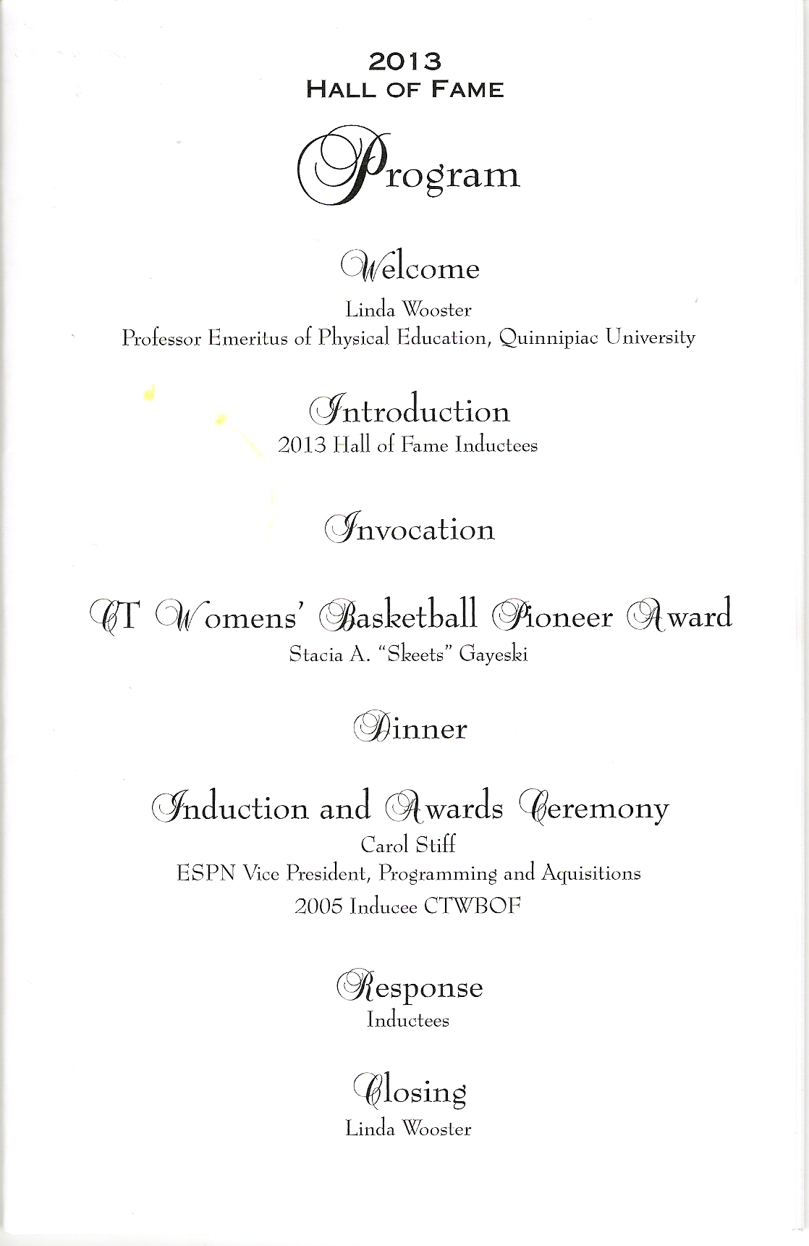
Skeets received the Pioneer Player Award from the
Connecticut Women’s Basketball Hall of Fame, awarded at their banquet April 24, 2013

Jack’s Lunch Speedgirls was a basketball team of Middletown, Connecticut locals and imports who played
and defeated the best female squads in the nation during their 4 season duration. They played at the State Armory at the south end of Main Street starting in 1933.
Jack Fitzgerald, owner of Jack’s Lunch, first decided to sponsor a men’s team – the Speedboys. In order to have two games a night, Jack put together a team of local girls to play the preliminary game. The Speedgirls quickly became the dominant team in the pairing. They, and not the men, were playing the feature game of the night. They won 29 and lost 1 game in their first season and won the New England (female) championship. Their captain was Marion Wells who then got married, had a son, and dropped from the team. By the second season the fans had to get there two hours early in order to not only get one of the 1200 seats, but sometimes to get into the games which had as many as nearly 3,000 attend.
Clarence McCabe was coaching the Speedgirls as well as the Speedboys. He hit upon an idea that made the Speedgirls strong enough to defeat the best teams in the country. McCabe went out and hired five guys who played for the Eagles, one of the best junior teams to operate out
of Middletown. The Eagles showed up at the State Armory one night a week to scrimmage the gals. There was no quarter given – and Artie Neville came out of more than one game covered with bruises. One night he emerged from a scuffle with a black eye.
Another player was knocked out for the only time in his basketball career that spanned about 15 years. Skeets Gayeski delivered the blow.

There was a previous girl’s basketball team named the Speedgirls formed in 1902 at Middletown High School. They wore bloomers, black stockings, and white blouses with a big black bow tie. The playing rules were different; players had to stay in their particular section of the floor.
The announcement of the end of the Speedgirls brought a note of sadness to those who loved the basketball sport. Beginning with their sensational climb in 1933 – 34, the Speedgirls the following season fanned the spirits of the basketball army to tremendous heights. Persons who had never seen the game and knew nothing about it came to the State Armory to cheer themselves hoarse for the nattily-clad and well-groomed Speedgirls. All they needed to know was that Kline or Baldwin or Gayeski or some other green-togged lassie had put the ball through the hoop and the cheering would ring through the drill shed.
Skill of the Speedgirls paved the way for one of the most remarkable of sporting epochs in Middletown’s history. Competition was soon lacking and it was necessary to go far a field for games. Many top teams in other sections were brought here. In the brilliant parade of nationally-known girls’ basketball talent which passed in review before the crowded State Armory galleries were the Beckwiths of Poughkeepsie, NY and other noted teams from nearby states which kept the fans at fever pitch in their enthusiasm for a season. When it became apparent that the Speedgirls were outclassing these teams the Cleveland girls, St. Louis girls, and the national champions, the Tulsa Oklahoma girls were brought here to provide exciting contests. The Speedgirls put Middletown on the map with their brilliant play.

When the Speedgirls were first organized in 1933, Stacia A. “Skeets” Gayeski was assigned to the left guard position where she was the defensive star for 3 seasons. Sports writers picked her as one of the best guards playing on girl basketball teams in Connecticut. She was 20 years old and had been playing basketball for five years. She was also one of the leading girl bowlers of the state, a fine swimmer, tennis player, baseball player, and musician.

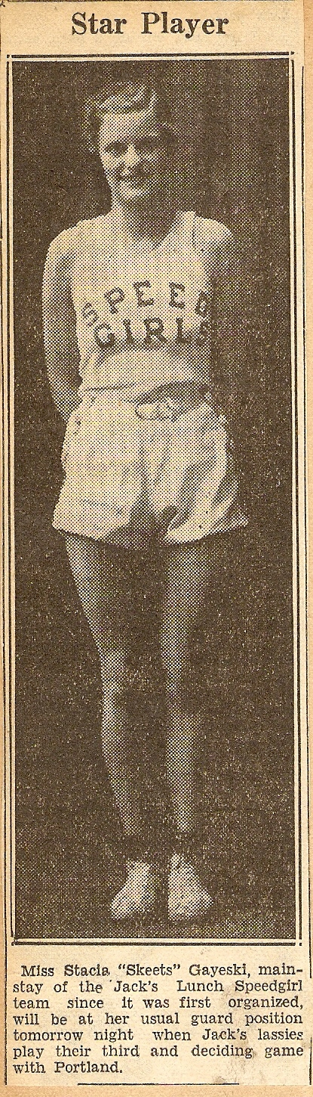

In the Middletown High School Senior Annual of 1931 “Skeets” was recognized as “Most Athletic Girl”. The Annual also described her as “She will give the devil his due.” The paragraph next to her picture: “Have you ever seen Stacia when she wasn’t pouring forth a flood of words, or when she wasn’t causing a storm of laughter? By the way, she’s the other half of those famous Baloney Sisters”.
The players elected Skeets Captain of the Speedgirls for their second season (1934 – 1935). They won 32 games and lost only one game that season. Skeets was known best for her leadership and her star defensive play.

Skeets had 3 sisters (Ann, Helen, and Mary) who were not noted athletes, but her 4 brothers were all star athletes. John graduated in 1931 with Skeets and he was captain of the Middletown High baseball team, played on the hockey team, was in the orchestra, and was an All-State football runner. Brother Walter was a star football player as well, and then played for a Middletown semi-pro team as their star runner. Frank finished high school with a much deformed nose from football. Eddie starred in baseball, football and basketball and continued baseball and basketball in the Army. None of the 8 Gayeski (originally Gajecki) kids went to college. Skeets worked as a clerk at the Industrial Securities Corporation while she was a Speedgirl.
The third season for the Speedgirls started with the shock of the death of the team’s owner Jack Fitzgerald, but the new Jack’s Lunch owner Maurice J. Higgins kept both teams going for a third and fourth season. Vida Bell was elected team Captain for season three and they had 25 wins and 4 losses. In their first 3 seasons, the Speedgirls never lost a series to any one team. At the end of year three they split one win each with the National AAU champions - - the Tulsa Oklahoma Stenos.
The Speedgirls were called the “Speed Maidens” by sports writers like Harold F. Scranton because of their unusual quickness. Coach McCabe told Scranton he pulled 4 of his “shock troop” starters when the lead was safe because if he left his regulars in the full game and had them going at top speed the game would be very one-sided and not so pleasing to the fans.
The Speedgirls were disbanded in 1937 after four seasons. Original Coach (then Manager) McCabe wanted to retire and owner Maurice J. Higgins wanted more time. The team didn’t elect a Captain the 4th year, they instead selected one before each game. The new coach was Bill Spear. Skeets Gayeski didn’t play the fourth year because she married U.S. Army Lt. John Clark Vaughan in 1936 and had a son in 1937. The four Middletown stars had left basketball - - Skeets Gayeski, Bernice Albrecht, Elsie Kline, and Vida Bell. After the last season, only Emma Anderson McMeken and Beatrice (Bea) White were left from Middletown, plus the 5’9” guard Catherine (Kay) Baldwin from Meridan. Nevertheless the team played its toughest schedule their 4th year, won 15 games and lost 7, and finally lost its only game series ever - - to Shaw-Stephens of St. Louis.
“Remember when I got to carry your bag into the games at the Armory and get in free?! At that time a quarter admission was just an impossible task. Our entire family of 10 people was just trying to survive.”
Skeets’ brother Eddie. While at Middletown High School Fred Post began covering local sports for the Middletown Press. He went to work at The Hartford Courant as a full time sports writer in 1939. He served in World War II on Iwo Jima and Okinawa as an Army Officer, earning two Bronze Stars. He then became sports editor for the Middletown Press. In addition to covering local sports he covered University of Connecticut basketball games. He also wrote a weekly sports column “Keeping Posted” for the Hartford Courant until shortly before his passing in 2007. He served as president of the Connecticut Sportswriters Alliance. Here is his last article on Skeets:
KEEPING POSTED May 06, 1998 By FRED POST
No Stopping This One, Once She Put On Her Sneakers
The last link with the famed Middletown Speedgirls passed away two weeks ago. Stacia (Skeets) Gayeski Vaughan died in Virginia and was buried in Arlington National Cemetery. She was the widow of an Army colonel. Skeets was a Middletown native who was one of finest defensive players in women's basketball during the heyday of female basketball in the East. She led the Speedgirls into national recognition that put them in the class of the Cleveland Fisher Food Girls, the St. Louis American Legion and the Tulsa (Okla.) Stenos, all of whom played the Speedgirls at the local State Armory. Gayeski and the Speedgirls were invited to play the Edmonton Grads in Canada for the world championship but the local women could not get the time off to play north of the border. The last letter I received from Skeets led off with: ``Dear FJay -- are you still knocking out girl basketball players?'' Actually, Skeets knocked me out in a game. I was a member of the Eagles, the best junior basketball team ever to play in this city. Coach Clarence McCabe hired the Eagles to scrimmage against the Speedgirls one night a week at the Armory. Skeets floored both Ole FJay and Bobby Neville in two different scrimmages. There will never be another team the likes of the Middletown Speedgirls ever again in this city. And Skeets Gayeski was a joy to watch perform against the best female players the country had in those days. She was the last of a select group of athletes -- and all we now have are some great memories. It was great knowing you Skeets. Farewell, Stacia.

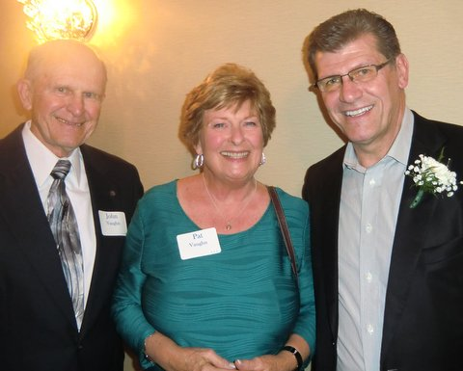
John, Pat and UConn coach Geno Auriemma

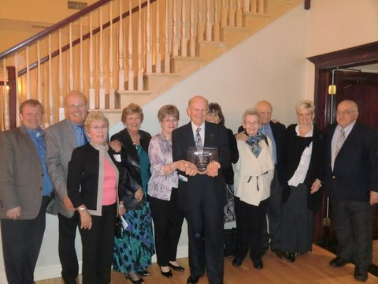
Skeets’ Family
John 4, Ken, Stewie, Pat, Ginny, Jack, Mary, Hilde, Ron, Jeanette and Tom

Basketball is Women’s #1 college sport and Division 1 colleges now average 1,583 attendance for women (and 4,994 for men). This makes the Speedgirl story more remarkable. Eighty years ago, Middletown with a population of only 26,000 would have 3,000 basketball fans lining up in the middle of the Great Depression to pay 25 cents to cheer for this now historic team. The Hall of Fame made Skeets their “Pioneer Player”.

