The First Four Heroes of American Liberty and Social Mobility--
Jamestown 1607

- America’s 400th Anniversary  - Indian life in Virginia in the 1600s  - Pocahontas’ view of London in 1616  - Captain John Smith was the Man | - Pocahontas, Rolfe, and Sandys  - Why are you here?  Appendix A. Selected Dates  Appendix B. River’s Edge

1. America’s 400th Anniversary

America was a privately owned, commercial company before it was a country. The Virginia Company of London was chartered in 1606 as an entrepreneurial effort. The investors were called “adventurers”. The business model was to (1) profit by finding gold or silver, and (2) to find a trade route by river through Virginia to the Pacific Ocean and the Orient. To help sell the idea, they added two good but lower priority goals of (3) converting the Indians to Christianity (Pocahontas was the first to convert) and (4) finding what happened to Roanoke Island’s “Lost Colony”.
They never made a profit, but by trying they started America. There was no gold and no trade routes to be found. They never converted many to Christianity. They never solved the Lost Colony mystery, although when Chief Opechancanough captured John Smith he told him of Ocanahonan, a distant settlement of men who wore English clothing.
It is probably most fortunate for the United States of America that Englishmen founded the Jamestown Colony in 1607 rather than the much bigger sea powers of the day like Portugal or Spain. Portugal had gone “east” and established trade routes by sea to the Orient. It circumvented the trans-Saharan spices, silk, and gold trade through the Ottoman Empire. By 1553 Portugal established coastal bases around Africa, India, and on to Macao, China. To bypass the Turkish controlled overland routes, Spain went “west” through the Caribbean and around South America to also find a sea route to Asia. It found gold in Dominican Republic and later gold and silver in Mexico and South America. Spain staged ships in the Pacific that shuttled back and forth from the orient via the Philippines. They transported the Asian spice, porcelain & silk across the Isthmus of Panama to load onto ships for Spain. When English privateers captured these treasure ships, they often held goods from Asia as well as bullion. Spain & Portugal were becoming powerful and wealthy, later followed by Netherlands and France. Why did this unimportant English Colony survive and then eventually grow to be one of the most prosperous countries in the world, while most of the other ex-European colonies are still struggling?
For example, when Portugal established a coastal base in Luanda, Angola in 1575 the warring African tribes plundered and sold each other into slavery in return for food and booze, rather than grouping together against a common enemy. Despite having great natural resources, including diamonds and oil, Angola is known today for landmines and high crime rate. On their 400th birthday in 1975, Portugal finally granted independence to Angola, but the old tribal rivalries remained, the government collapsed, the Portuguese fled – half a million left in the biggest airlift in history, converting downtown Luanda into a ghost town and robbing the country of its administrative and technical expertise. Over the past 40 years Angolans have known more war than any other African country.
As you read about all the many mistakes and miscalculations made by just about everyone involved in our earliest beginnings, you may wonder how we ever survived our birth. It turned out as few as four people were the primary characters in making it all possible during those first seventeen years as a struggling enterprise settlement.

Someone could make a comedy movie of Jamestown and it might be titled “Why are you here?” as the Indians asked. Or “Why are they there?” as the Spanish Ambassador to England asked. Even, “Why are we here?” as the early settlers or first uninvited slaves from Angola surely must have asked themselves. King James of England and King Phillip of Spain did not see that anything significant could come from the Jamestown enterprise.

We have a simple 400-year history:
17 years = | 1607-1624 | Settlers for the Virginia Company of London
157 years = | 1624-1781 | Colonialists under the Royal Colony of the King of England
226 years = | 1781-2007 | Citizens of the United States

Just this year, James City County (which includes Jamestown and Kingsmill) joined the ranks of the top 100 (75th) fastest growing cities/counties in the U.S. So on our 400th birthday the Virginia enterprise and dreams are continuing to grow.
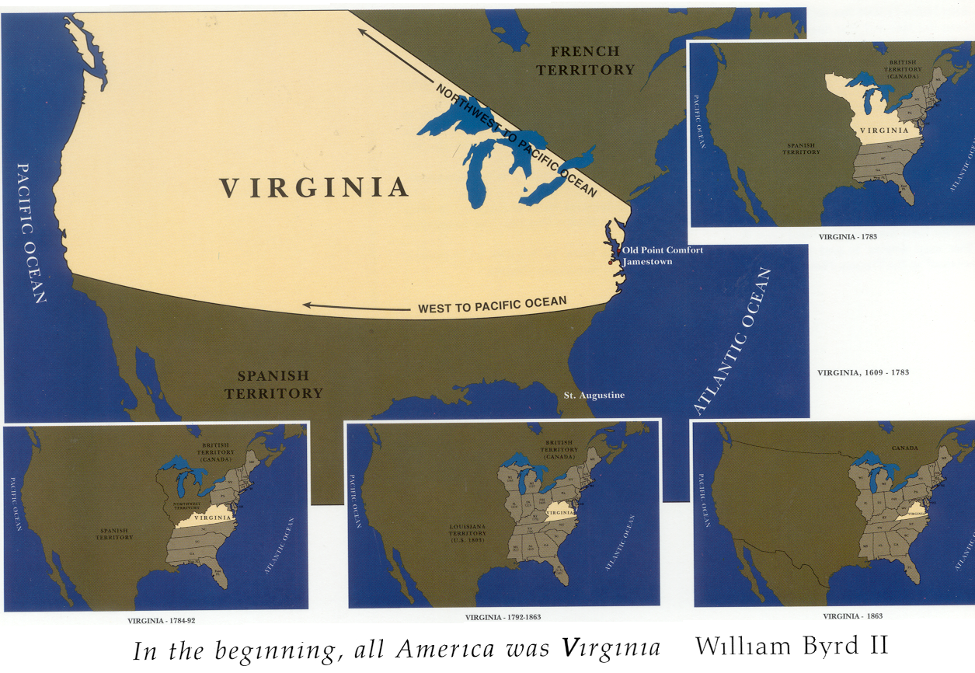
1784-1792
1792-1863
1863
1783
VIRGINIA, 1608-1783
FRENCH
TERRITORY
SPANISH
TERRITORY
King James I’s second charter to the Virginia Company of London (in 1609) gave it the right to settle anywhere between the 34th and 41st degrees of latitude. That meant that Virginia extended from Long Island (New York) to below Cape Hatteras and westward all the way to the Pacific Ocean. When the Treaty of Paris ended the American Revolution in 1783, the boundary was set between the new United States and British Canada. Lands west of the Mississippi River – claimed by Virginia under the 1609 charter – were acknowledged to belong to Spain, which had also fought Great Britain from 1779 to 1783.
During the Revolution Virginia sent George Rogers Clark to the Illinois and Indiana country to expel the British from areas that were claimed by Virginia. In December 1781 Virginia agreed to cede its territories north of the Ohio River to the Confederation Congress, which later made the area the Northwest Territory. The formal cession took place in 1784.
On December 31, 1776 Kentucky became part of Virginia and remained a county until it was admitted to the Union as the fifteenth state in 1792.
Fifty northwestern counties in Virginia refused to join the Confederate States of America. In 1863 the United States Congress admitted them to the Union as the state of West Virginia. The boundaries of Virginia have remained the same since then.
- Indian Life in Virginia in the 1600s

The Paleo-Indians were originally believed to have arrived in Virginia over 16,000 years ago by migrating from Asia across to Alaska on Siberian glaciers and then moving south to the Americas. This is now considered an out-of-date theory. New theories abound, such as Solutreans from Europe. Possibly DNA studies will help explain where these people came from.
In 1606 Spain dominated most of South America, Central America, Florida, Cuba and the Philippines. Even Portugal was under the Spanish crown from 1580 to 1640. The conquistadors built a well-deserved reputation for being brutal. The Aztecs, Inca, and Maya knew this well.
The Powhatan Indians in Virginia also hated the Spanish. They came to the Chesapeake Bay around 1560 and captured a teenage Powhatan boy. He was educated in Mexico and Spain and then brought back to Virginia ten years later to help establish a Catholic mission. He fled, returning to his own people. The Powhatans took revenge on the Spanish by killing the missionaries. In 1572 the Spanish sent a gunboat and retaliated. The Powhatans memory of the affair was still fresh when the English arrived in Jamestown.
The Powhatan Empire in 1607 covered all of modern eastern Virginia. It was well organized and the approximately 14,000 Indians lived well. Males of the empire were trained from early childhood to be hunters, fishermen and warriors. Their arrows were deadly accurate at 40 yards. They could shoot down birds in flight. They had no wheels, metal, guns or cannons like the English, but their 3-foot arrows could penetrate targets that a pistol shot could not go through. They certainly could reload faster.
Chief Powhatan was a very healthy man age 60 or 70, who ruled over about twenty-eight tribes located along Virginia’s rivers, east of modern I-95 from Washington, DC (Potomac River) through Fredericksburg (Rappahannock River) and Richmond (James River), to today’s North Carolina line. His capital (called “Werowocomoco”, or “chief’s place”) was on the north bank of the York River. Recent digs and carbon dating have revealed it was the location of an Indian village since the year 1200 - - 400 years before Jamestown. Just downriver and across on the south bank is Yorktown where General Cornwallis surrendered in 1776 to give us independence from England. A short distance across the peninsula from Yorktown is Williamsburg and the Jamestown site on the James River. This is called America’s historic triangle, (Jamestown – Williamsburg – Yorktown).
The Indians led a simple life in Virginia. Their homes were all the same design, just varying in size. Most were built under trees. They had rounded thatched roofs and walls of reeds covered with tree bark. Mats covered the entrance. No windows (no glass). Some had scaffolds hung with mats to serve as covered porches. They ate well. Unlike the English settlers, they never were known to have run out of food except when their storehouses were robbed or burned. They grew corn, squash, and beans, they picked herbs and fruit, and they fished from canoes and dug oysters. They hunted deer, rabbits, squirrel, turkey, and birds. They had fresh water and no alcohol. The tribes contributed grain to Powhatan’s storehouses. The men painted their bodies’ colors such as red or black, their faces sometimes blue with dots. They wore deer loin skins and fox or other skin on their arms, raccoon skin robes and decorations made from bones or pearls. They shaved the right side of their heads with sharp shells and let the left side grow three to four feet long, tied with a knot and decorated with feathers.
For ceremonies they would dance, stomping their feet in unison but all doing their own movements and yells. They played flutes made of reeds. They had no written language. They spoke Algonquian. The women and children did all the work except hunt, fish, and fight. They planted and harvested the corn, wove baskets, and made clay pots.
The Powhatan custom was to take leaders alive if possible (this helped save John Smith when he was captured). Chiefs of enemy tribes, like women and children, were kept in servitude, not killed. Native chiefs would provide honored guests with a bedmate. Chief Powhatan had a hundred or so wives and many children. Wives were “divorced” after they bore a child. His favorite was a daughter nicknamed Pocahontas – “little wonton” – for her feisty, mischievous nature. She was between ten and twelve years old in December 1607 when she first met John Smith.
Line of succession after Powhatan was his brothers, to his sisters, and then to his sister’s children. Pocahontas’s mother raised her through her earliest years, and then Pocahontas was taken away from her mother to be raised in Chief Powhatan’s household. Her mother became a commoner again. That was the custom. So Pocahontas had little future with her people, and when she was kidnapped by the English her future at first looked even bleaker. She adjusted to many English ways and in 1614 married John Rolfe (age 28).
When Powhatan died in 1618, one brother was too old to become active chief, so the second brother, Opechancanough, took over as leader. He was always determined to destroy the English. On March 22, 1622 they attacked and killed almost 400 of the 1240 English in Virginia. John Smith and Pocahontas were long gone from Virginia and the inevitable attack finally happened, but by this time the English could survive and attack back. King James dissolved the Virginia Company’s charter in May 1624 and Virginia became a Royal Colony for the next 157 years.
During the March 22, 1622 raid about 20 female colonists were captured from the plantation of Martins Hundred where fifty-two men and six children were killed. Martins Hundred was located where Carter’s Grove is today, just southeast of the present day Kingsmill community. It took a year for the English to learn that the women were still alive as slaves at the Chief’s village. In March 1623, Opechancanough promised to return the women as part of a truce offer. Mistress Boyse attired as an Indian “queen”, was the first released. Near the end of 1623, Dr. John Pott, Jamestown’s resident physician, ransomed Jane Dickenson and other women from the Indians for a few pounds of beads. She then owed a debt to Dr. Pott for the ransom he had paid and for the three years of service that her deceased husband had left on his contract of servitude at the time of his debt. She complained, but was not “released” by Dr. Pott until March 1624. One captive, Anne Jackson, was not returned to the English until after eight years of captivity. About half of the women never returned and their fates remain unknown.
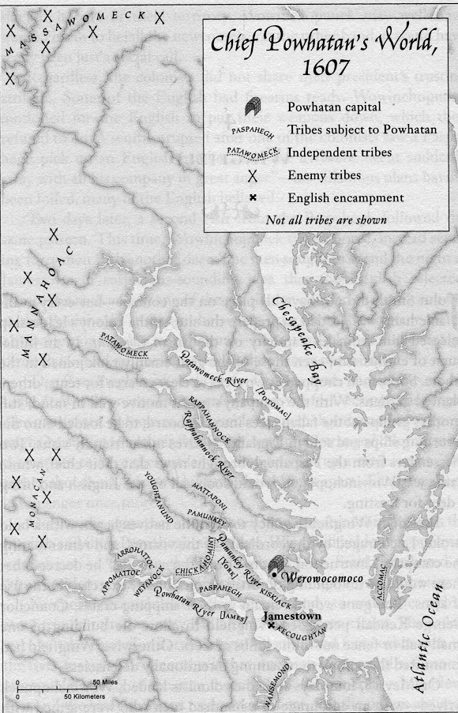
Opechancanough attacked again on April 18, 1644 and killed more than 400, but the impact was less because the English population had grown six fold. Two years later Opechancanough was captured and killed in prison. He was about 100 years old.
By the year 1700 the Indians in Virginia had dwindled to about 600 and their lands down to a few small reservations.

3. Pocahontas’ View of London in 1616

When Pocahontas entered England in June 1616 she saw something quite different from Virginia. Their ship landed in Plymouth. She and John Rolfe then traveled by coach for 180 miles to London. They bounced along dirt roads in the countryside and cobblestones in the towns. She passed many meadows with grazing cattle. Then came the slums outside London. Severed heads of convicts were mounted on pikes on London Bridge. She saw for the first time stray dogs, street peddlers, and a city population of 200,000, as well as stores and open stalls, and some houses five or six stories tall.
The foul air would take her life in a year. She was overwhelmed by the wood smoke and coal soot. Everyone coughed. There was horse dung on the streets and open latrines, taverns, and pipe smoking. There were signs and books (talking papers to Indians).
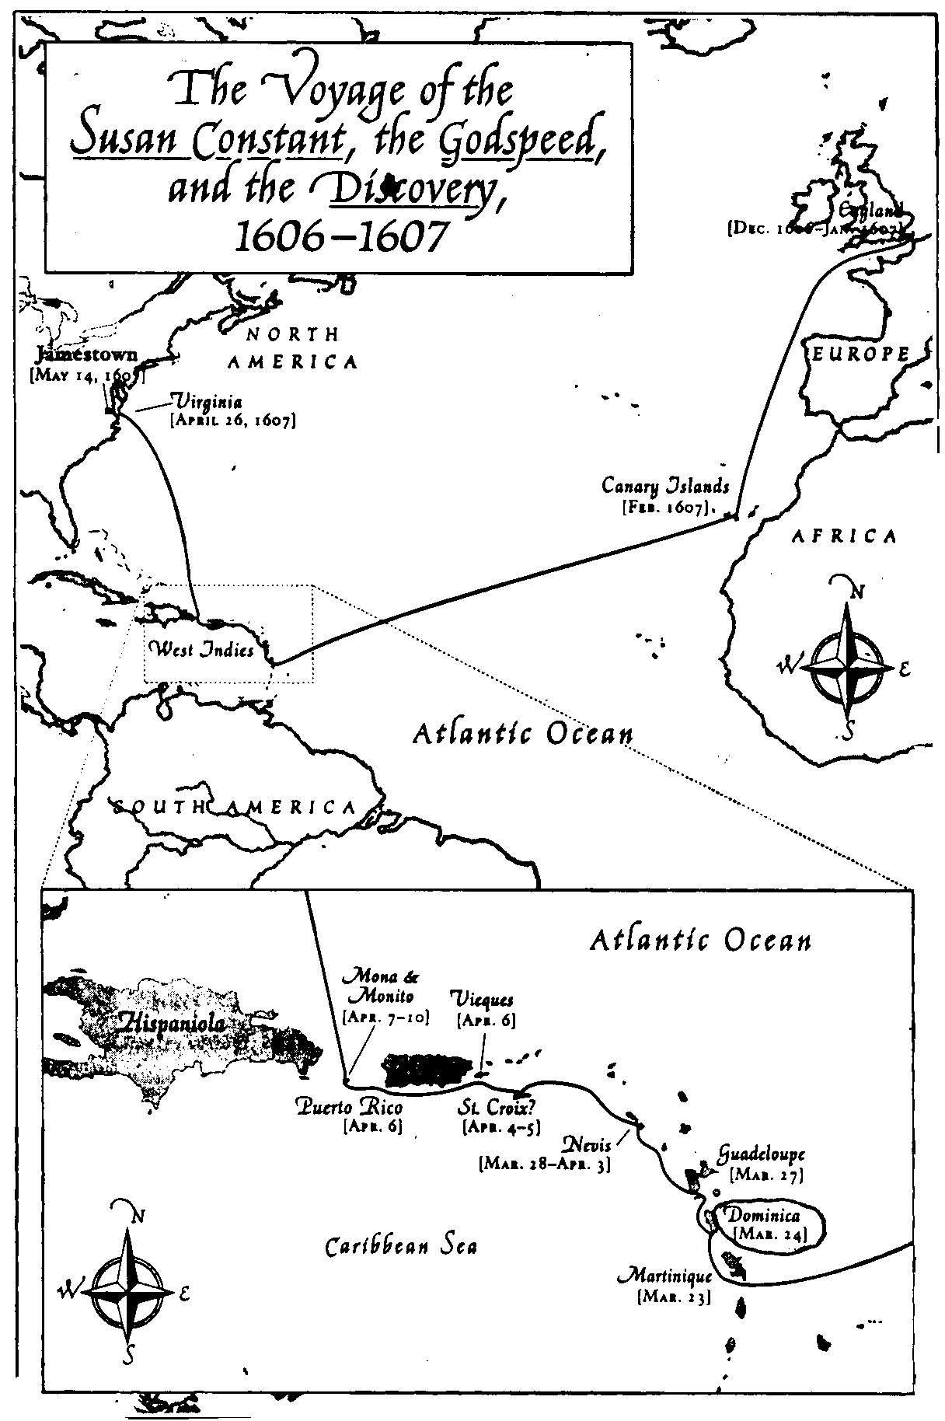
Pocahontas still believed the lie she was told in 1609 that John Smith was dead. She met King James. Earlier in his reign the king was handsome, noble, and jovial. But at age 51, a lifetime of gluttony and immoderate drinking had reshaped his head and body. His teeth were falling out so he gulped food instead of chewing. He wouldn’t change his clothes. He was prone to excessive sweat, but he wouldn’t bathe. He had uncouth manners and had contempt for women. What a contrast to Chief Powhatan and Virginia!
It is interesting that, despite the king’s shambling appearance and doubtful hygiene, he was repulsed by the tobacco habit. As early as 1604, King James wrote this about tobacco: “A custom loathsome to the eye, hateful to the nose, harmful to the brain, dangerous to the lungs, and in the black stinking fume thereof nearest resembling the horrible stygian smoke of the pit that is bottomless”. How ironic that John Rolfe’s tobacco would prove to be the economic savior of England’s venture across the Atlantic.
Pocahontas was a curiosity in England. London offered much to a lively woman of twenty-one. She also had the company of other women (still sparse in the colony).
Tomocomo, the Indian who accompanied Pocahontas to England and returned to Virginia with John Rolfe, found little to like about English society. Rolfe wrote to Sir Edwin Sandys in June 1617 and described how Tomocomo reported his dislikes to Powhatan and his brother Opechancanough.

4. Captain John Smith was the Man

There are several things that most people don’t know about Captain John Smith of Jamestown fame. He was a “Captain”. It sounds like he was in charge and had an elevated position, but in the class-conscious society of that day he was a “yeoman”, just above “poor” or “worker”, and below “citizen and burgesses”, and far below “gentry”, much less “nobility”. The “gentlemen” class looked down on him and cared not to associate with him if possible. Although he highly praised Pocahontas, and owed his life to her twice, he never had a romantic relationship with her. If it were not for Captain John Smith the Jamestown Colony would surely have failed. Even with him it still would have failed, like Roanoke and the other English failures before, if not for what some would call miracles or divine interventions. Captain John Smith was the #1 key person responsible for Virginia’s survival. He was granted status as a gentleman in Transylvania. His coat of arms was eventually accepted by the College of Arms in London, conferring gentleman status on him there as well even though men such as Wingfield refused to accept Smith as a gentleman.
Smith had one key fault that hurt all his relationships with superiors, but it didn’t stop him from doing the things that were needed for this country’s start. He lacked the patience and diplomacy to hide his disgust with the foolishness of influential people. Smith valued effectiveness over internal politics, but could not understand that playing internal politics was sometimes part and parcel of effectiveness. On all other skills he scored an A+.
Smith was born to a simple farm family in Lincolnshire, England in 1580. He was slightly below normal height, even by standards of his time, measuring five-foot-four, but he was stocky and tough. Soldiering was to be his way out. At age thirteen he tried to run away from home in hopes of foreign adventure. His dad stopped him, but when his dad died four years later, Smith went to the Netherlands and fought to help them win independence against Spain. He became an expert in all practiced military knowledge such as explosives, codes, and languages. He also read extensively on military tactics, philosophy, and biographies. In 1601 he enlisted with Austrian forces in Hungary that were fighting the occupying armies of the Turkish Ottoman Empire. The Muslim superpower had conquered much of Central Europe, North Africa and the Middle East. He earned the title of Captain and received a lot of respect. The Prince of Transylvania made Smith a gentleman in that society by the grant of a coat of arms with three severed Turks heads in recognition of his valor in single combat against the Turks there.
Then came the first of his four captures and confinements. In the winter of 1602 he was captured on the battlefield in Romania and sold at auction into slavery. He ended up on a Turkish farm under a cruel master with hundreds of slaves-European, Turk, and Arab. His fellow slaves informed him that escape was impossible. When the master was beating him one day, he turned and beat the man to death, put on his clothes and rode his horse to friendly territory. He was later picked to go on the first three ships to Virginia because of his demonstrated ability and experience in Eastern Europe among foreign cultures and in hostile situations.
When the Susan Constant and its two smaller escort ships stopped in the Canaries for fresh water on the way to Virginia, Smith had his second confinement. His lack of patience with the on board powerful and clueless gentleman Wingfield ended up in trumped up charges of plotting an insurrection. During bad weather earlier on the trip Wingfield and others of high rank were ready to head back to the comforts of home, but Smith successfully argued against them. He became a jailhouse writer during the rest of the voyage to Virginia. This is fortunate because Smith wrote without an agenda, except possibly his own. Most everything else written at the time had great distortions and embellishments in order to appeal to investors. One of the rules of the Virginia Company was that no letters back home could say anything negative. Nevertheless, by 1612 English investors had given up on the Virginia Company. The only way to raise money for the next ten years was to run a lottery.
Smith was saved this time by a surprising decision made back in England before sailing. The Virginia Company commanded that 24 hours after arriving on the Virginia coast, the sealed orders would be opened to tell who would be the seven men to govern as members of the colony’s ruling council. The list had six gentlemen and Smith! The six elected Wingfield president and Wingfield decided to not allow the riffraff Smith on the council. At least he got out of thirteen weeks of confinement because the 105 men had work to do, and gentlemen didn’t work. Smith was eventually admitted to the ruling council.
On May 12, 1607 the three ships stopped at a point on the James that gentleman Gabriel Archer felt was an ideal place to put down stakes. He thought it would be easy to defend against a Spanish incursion, unlike much of the frontage on the winding James. It afforded an unobstructed view of the river for miles downstream, and thus of any approaching ships. The soil was rich. Rabbits, a staple of the English table back home, were abundant, as were turkeys and turkey eggs. This site is near the present-day Kingsmill residential community. However, the Jamestown site had one advantage over the Kingsmill area. It had deeper water, so the large ships could pull up directly alongside to be moored to the trees and offloaded.
Wingfield selected the site for Jamestown five miles further upstream, over the objections of some of the gentlemen who favored Archer’s choice and in violation of orders from the Virginia Company. Nevertheless, this spot at Jamestown is where the United States of America really began. The company said to go 100 miles upriver from the mouth of the Chesapeake Bay, but they went only fifty miles. Another seven miles up the James, where the Chickahominey River joins, they would have had fresh water to drink all year long. The company also urged them not to settle in “a low or moist place”. They picked a humid marshy area with mosquitoes that was unsuitable for planting food. They thought it would be easy to defend against a Spanish attack that never came. However they did one thing right. They did as instructed and chose a place uninhabited by the natives. England strongly believed they could live at peace with the Indians, keep clear of their villages, make friends, and convert them to Christianity.
About six months later Smith was captured again. This time it was by the Indians. He was way up the little Chickahominy River looking for a passage to the Pacific! A laborer, George Cassen, was captured and skinned alive, but Smith used great oratory and magic with his compass to bluff the local Chief Opechancanough into keeping him alive as a person of great importance. No Englishman had yet laid eyes on Chief Powhatan or even knew his whereabouts. On December 30, 1607 Smith was brought to the famous, gray-haired emperor with the physique of a young strong man. Smith told tall stories with gestures and basic Algonquin of why he was in Virginia and why so far from camp. Powhatan wasn’t impressed and ordered his brains be beaten out with clubs. Young Pocahontas rushed to shield Smith and the chief was won over by his daughter’s plea.
Smith happily returned to Jamestown on January 2, 1608 only to find that about twelve gentlemen were commandeering the Discovery in an attempt to head back to England. Only 38 of the original 105 colonists were left alive. Most of the others had starved because they wouldn’t work or had no survival skills. They were still waiting on food from England which was two months late. So the gentlemen were taking the small third ship, which was left behind from the original three ships. Smith ordered cannon and muskets trained on them with an ultimatum to stay or be sunk.
Smith already had Wingfield removed from the council when he found Wingfield was surviving better than others because he kept a hidden food supply. The new council of gentlemen wanted to get rid of Smith even more now, so they trumped up charges again and sentenced him to hang. As Smith was dining on his last meal, his second one in a week, he was blessed with another stroke of luck. Christopher Newport, the ship captain who sailed the original Susan Constant that brought Smith to Virginia, reappeared in Jamestown with the “first supply” and finding the colony in chaos, took command. He quickly saw through the new president’s charges and released Smith.
In June 1608, re-supply ship captain Thomas Nelson brought back to England a manuscript of more than 13,000 words plus maps of Powhatan’s tribes written by Smith. Without Smith’s knowledge, his work was edited and published as “A True Relation…” and was the earliest history of English America’s successful birth of a permanent settlement. It was written by a soldier with a grammar school education.
In July 1608, Smith almost died from a string ray fish poison in his arm. They even dug his grave this time. Smith unexpectedly survived and ate the stingray for supper. Smith continued to be a survivor. In January 1609 Pocahontas saved Smith again at Powhatan’s camp. Smith was there to trade for corn again and Pocahontas came to tell him that her father was going to kill Smith and his men after dinner was brought to them. If a sentry had spotted her and reported back to Powhatan it would have been the end for her.
Smith finally became president of the council from September 1608 to September 1609. The biggest thing he changed was that if you did not work you did not eat. This was alien to the gentlemen but it proved effective. They built twenty houses, dug a well for clean, fresh water and planted forty acres with the advice of the Indians. A checkpoint was built at the neck of the peninsula and guarded at all times. The mysterious pilfering of the colony’s weapons and tools came to an end. In August of 1609 the first four ships of the nine ships of the “third supply” arrived in Jamestown. Smith learned that the Virginia Company changed its charter and replaced the president and council with a single governor. He was on his way on another ship.
Shortly after that, Smith had his last brush with early death. He had stretched out for a doze during a sail back to Jamestown. A spark landed on the powder bag he was wearing. He was badly burned in a 10-inch square. He leaped overboard to quench the fire and almost drowned before his men could pull him out.
In agony, and scheduled to be replaced by a gentleman governor, Smith decided to return to England with the supply ships. His emotions were likely still raw and confused, a brew of outrage, betrayal and bewilderment. His career abroad had peaked but he didn’t know it. He had saved the colony but would receive no appreciation for it from the gentlemen. His antagonists, unenthusiastic about the idea of him speaking freely in London and pointing fingers, ordered the ships not to leave yet. For the next several weeks, when the council ought to have focused on building up the food stocks, it instead spent its time collecting denunciations of Smith from everyone he had ever punished or contended with.
After Smith’s departure, the colonists told any natives that inquired about him that he was dead. Pocahontas heard this and accepted it as true. She turned her back on the colony and would not return to it for another four years – as a captive herself. Once the natives comprehended that Smith was out of the picture, Powhatan saw an opportunity to wage war on the colony. Rather than an all out attack he figured they would starve to death without the food that Smith was so good at wrangling from the Indians. Men who came to the Indians to trade for food were killed and their mouths stuffed with bread. One of the council was captured and skinned alive and then burned at the stake. By March 1610, six months after Smith had gone, 60 colonists out of 500 in Jamestown were left alive. Most starved. Cannibalism was needed by some to survive. One Indian was killed during an attack and buried; a group of colonist dug him up several days later and ate him. The “starving time” never had to happen. One survivor wrote … “had we been in Paradise with these governors it would not have been much better for us”.
When the new governor, Gates, finally arrived via Bermuda in May 1610 he saw no signs of life. He rang the church bell and the few left alive staggered out as walking skeletons. Gates decided after three days to abandon Jamestown. Everyone was happy to leave; Gates had to post guards to prevent the colonists from burning everything to the ground as they left. The four ships, with everyone on board, sailed just one day towards England and encountered an unidentified ship on the James River approaching them. The ship was the first of three ships carrying 150 new settlers and a new governor, Thomas West. No one knew they were coming. They had sailed from England on April 1, 1610, ten months after Gates. But with Gates being shipwrecked in Bermuda for nine months, the two “new” governors were arriving within a week of each other. West ordered Gates back to Jamestown. West’s cargo had enough food for a year.
John Smith’s passion, for the rest of his life in England, remained the settlement and growth of an English New World. He channeled his energies once again to writing. He saw two potential attributes of the New World that could be as enticing as gold. The first was social mobility. He said that poor men with ambition could make new destinies for themselves. The vestiges of feudal institutions and feudal ideas could be left behind. The second attraction that Smith saw in America was liberty. He wrote: the liberty to pursue one’s own interest was not only mankind’s proper condition, but also an engine that could power a society to greatness. He was writing a century and a half before the Scotsman Adam Smith set out his famous union of self-interest and societal well being in The Wealth of Nations.
John Smith died in 1631 at age 51. He never married and left no offspring. The heart of the new nation-the values and hopes that were everywhere in the air-shared Smith’s individualism, practicality, disdain for class rank, and esteem for those who worked hard to get ahead. A French aristocrat turned New York farmer named J. Hector St. John de Crevecoeur was awestruck by the unique breed of humanity that America was creating. He wrote in 1782 that the American was “a new man, who acts upon new principles.”
- Pocahontas, Rolfe, and Sandys

Less is known of Pocahontas because she came from an Indian culture with no written language. George Bancroft’s highly successful History of the United States in 1834 held Smith to be “the father of Virginia.” If Smith represented the proto-American man for Bancroft, Pocahontas seemed to stand for the proto-American woman, possessed of both “gentle feelings of humanity and fearlessness.”
Pocahontas was the first of the Indians surrounding Jamestown to learn to speak English and to become Christian. She also was the first to have a child in marriage by an Englishman. Smith credited her with saving the colony. She was a child of privilege in her society who was curious about the English newcomers. She befriended Smith, and gave him and the rest of the English crucial assistance. The English in Virginia, for their part, chose a strange way to repay her: Four years after Smith left the colony; they kidnapped her and held her hostage for ransom from her father, Chief Powhatan. Yet during that time of captivity, she came to embrace English ways. She married a thoroughly love struck Englishman named James Rolfe, and had a son Thomas. She died suddenly in England at the end of her first visit there.
The things that happened to John Rolfe certainly made for an interesting life. He and his first wife were on board the Sea Venture which left England on June 2, 1609 to resupply Jamestown. There were nine ships under the overall command of Sir George Somers, the fleet’s admiral. The Sea Venture was his flagship. Also onboard was Governor Gates, who was to take over leadership of Jamestown from the President and the Council. Fortunately for the voyagers, Somers was a rarity among Virginia leaders, a man of combined elevated social position with John Smith’s practical effectiveness. On July 24, just eight days from Virginia, an unusual storm tossed the ships for four days. The other eight ships made it through to Virginia, where the Starving Time winter of 1609-1610 awaited them. The storm probably saved John Rolfe’s life. The Sea Venture took the worst of the storm. The fury of the storm was outrageous. The caulking gave way and they started to sink. The men bailed furiously with buckets or pumps and water to their waists for an hour, rested in shifts for an hour, then worked again. They continued for three days without eating, drinking, or sleeping. When the skies cleared they were in sight of Bermuda, which is surrounded by perilous rock and coral shoals. Somers made a controlled wreck into V-shaped coral to hold the ship. The island was uninhabited with plenty of natural food and wild hogs left there by the Spaniards. It took nine months for Somers to organize building two small ships from the wreckage of the Sea Venture. A girl was born to Mr. & Mrs. Rolfe in February 1610, but Bermuda Rolfe died there. After continuing on to Virginia, John Rolfe’s wife died there. In 1614 he met Pocahontas as she was being held captive. She had vitality, intelligence, and good looks. She was exotic and Rolfe could think of nothing but her. Their marriage brought about a temporary peace with the Pohawtans for eight years.
Rolfe was not the superior hunter that Pocahontas was raised to admire, but he was handsome and he was developing what the colony needed – a financial reason to be there, tobacco. He saw tobacco as a possible export crop and was tinkering with the planting of varieties from the Caribbean and South America. England would soon no longer have to buy Spanish tobacco. Rolfe sent his first tobacco to England in 1614. Exports grew from 2,300 pounds in 1616 to 500,000 pounds by 1628. It wasn’t gold, but it led to a local “gold rush”. People were earning or being assigned their own private land. Opportunity was overcoming the 1622 massacre by Indians.
In addition to Smith, Pocahontas and Rolfe, a fourth individual seemed destined to be a key to America’s start up. King James said in 1620 that Sir Edwin Sandys was his worst enemy. Why? Sandys, the son of an archbishop, entered Oxford at age fifteen and received his BA two years later. He emerged with a fluent command of Latin and Greek. He was a Member of Parliament at twenty-eight, and became involved in the Virginia Company in his mid-forties. He wore a trim, pointed beard of an aristocrat, but his notions of government were antiroyalist – as far as they could be without causing the separation of his head from his neck. He framed his arguments within a doctrine of natural rights, that is, rights that individuals possess innately, independent of any grant by a sovereign. Sandys’ maverick philosophy created the Virginia House of Burgesses, English America’s first representative legislature. Although Sir Edwin was the chief executive officer (treasurer) of the Virginia Company in London in April 1619, he never traveled to Virginia. His brother, George Sandys, was the colony’s treasurer in Virginia in 1623, one year after the first of two big Indian attacks. King James used the 1622 attack as justification to eventually withdraw the Virginia Company charter (and Sir Sandys’ influence) on May 24, 1624. Virginia became a royal colony, but Sir Edwin’s work had already been planted in Virginia. The House of Burgesses had been meeting in Virginia since July 30, 1619. Broad-based property ownership also started then.
By strange coincidence, American democracy and American slavery put down their roots within weeks of each other. A Dutch man-of-war showed up unexpectedly and dropped off twenty slaves pirated from a Portuguese slave ship headed for Mexico. They probably received the legal position of indentured servant, like many of the white newcomers, eligible for freedom after completing a period of service. Hereditary slavery records in Virginia do not appear until the 1640s. Virginia law in 1619 made no provision for hereditary slavery. One of these early arrivals not only became a free man under the name Anthony Johnson, but a farmer of substantial means. He had 250 acres of holdings in 1651. By 1654 he was a slave owner himself.
There is a granite gravestone on the west end of the eagle area in Kingsmill, at the entrance to the River’s Edge parcel. The sign reads:

UTOPIA SITE

Researchers from the James River Institute of Archaeology discovered the remains of 25 enslaved Africans and their descendants located in a cemetery near this site at a slave quarters known as Utopia.
The land where the cemetery was situated was owned by the families of Colonel Thomas Pettus and later by James Bray.
It is estimated that they lived between the seventeenth century (ca 1690) and early eighteenth century (ca 1770). America was not yet a nation during their lifetime.
The remains of their bodies were moved to protect from further deterioration and are buried under this monument. Their souls are forever free.

Chief Powhatan’s world in 1607 was changed completely by Smith, Pocahontas, Rolfe, and Sandys. His lands were taken over by English settlers. Five U. S. presidents were born in the 1700s on lands originally controlled by Powhatan: George Washington, James Madison, James Monroe, William Henry Harrison, and John Tyler.
Six of the original Powhatan tribes have survived these 400 years. Two tribes have their own reservations, just 8 miles apart on small rivers leading into the York River. The Mattaponi reservation was granted by the Virginia legislature in 1658. Approximately 70 of the 450 members live on the reservation and worship as Southern Baptist. The Pamunkey reservation has 100 residents.
The other four tribes operate without officially-recognized reservations, but most members still live near their original villages. Approximately 750 Chickahominy people reside within five miles of their tribal center. The Nansemond tribe numbered 1,200 in 1607 and has 300 today. The Rappahannock tribe now has their first woman chief since the 1700s. Their cultural center is planned for completion in 2007. The Upper Mattaponi number 500 and their tribal center is the only public Indian school building still existing in Virginia. Life goes on despite the vicissitudes.

- WHY ARE YOU HERE?

The American enterprise survived its earliest years by a thin thread. The Virginia Company in London that lured all the original investors had it wrong. There was no gold and no passage to the Pacific. The Native Americans knew this and so did the powerful Spanish. The original settlers certainly would have wondered why they were there as they were starving and falling from diseases, but they were not allowed to return on the resupply ships. Even our four heroes – Smith, Pocahontas, Rolfe, and Sandys – had no correct visions in the beginning. The three most powerful people – King James, Chief Powhatan and King Phillip III of Spain – couldn’t see where this was all going. Either Powhatan or Phillip could have easily wiped out the Jamestown settlement in the beginning, but neither of them heeded the advice of their closest advisors, probably because neither advisor knew what Jamestown was really about. They were in the “same boat” as the people in Jamestown themselves. Sort of clueless. The fact that lying, cheating, stealing, arrogance, poor decisions, cover-up, foolishness, or bluffing were common practices for just about everyone involved didn’t help for any clarity.
Opechancanough started out the questioning in Virginia when Captain John Smith was captured around Christmas 1607 and brought to him. Opechancanough tied Smith to a stake and planned to question and torture him to solve the puzzle of the English presence. Instead he brought Smith to Powhatan (and Pocahontas), where the Chief had the same questions. Why had the two big ships gone away? Why did they locate on the mosquito infested, marshy peninsula of Jamestown where you couldn’t plant, and so far south on the river that the water was too brackish to drink? Why did the English live without women? He certainly would not have believed Smith’s hand gesturing broken-Algonquin language explanation that he was “bird hunting” when found fifty miles upstream on the tiny Chickahominey River. Smith tried that explanation when first captured, but didn’t try that in front of the Chief. Smith didn’t want to tell them his real secret mission, looking for the Pacific Ocean, not realizing it would have been great for laughs. Opechancanough still remembered the Spanish misdeeds to his people in 1560 and 1572 and advised strongly that Jamestown be wiped out, but Chief Powhatan never acted forcefully enough. When Opechancanough finally took over after his brother’s death in 1618, it was too late.
Back in London, Don Pedro de Zuniga was the Spanish Ambassador. Zuniga was intelligent, well connected, and had spies in the English government. He could meet with King James and write back to King Phillip. On October 7, 1607 he got an audience with King James about Jamestown. He told James that Virginia was in a region the Spanish regarded as theirs and theirs alone – an extension of the Indies they had dominated against other Europeans since 1492. He gave a thinly veiled threat of retaliation. James replied that he was unaware that Spain had a right to that territory, but those who went did so at their own risk. If they were captured or punished, so be it. Zuniga wrote to Phillip the next day. “I think it would be a good idea if the few who were there should be finished outright, because that would cut the root, so that it would not sprout again.” Zuniga further wrote, “It is thoroughly evident that it is not their desire to populate the land, but rather to practice piracy.” Philip wrote back a few weeks later thanking Zuniga for keeping an eye on the situation.
Zuniga tried once more in 1609 to get Philip to act. The Virginia Company needed a new round of funding. They hit on a promotion strategy enlisting clergymen – who believed the New World ripe for Christian evangelism – to support the stock offering by spreading the word from the pulpits. The gold and Pacific passage reasons were wearing thin with savvy investors. Zuniga wrote, “They collected in twenty days an amount of money for this voyage that frightens me.” Again, King Phillip did not act.
Some of the most confused were the first slaves. They certainly had to ask themselves “Why are we here?” They came from the Ndongo kingdom, 125 miles inland from Luanda, Angola. Their village of 5,000 thatched homes was twenty or thirty times as populous as the Virginia Colony in 1619. They lived in a cool, elevated territory and could feed themselves well. They planted crops and could work iron into tools and weapons. They were seized by the evil Imbangola marauderers and sold as slaves to the Portuguese to be later sold in Brazil, Mexico, and the Caribbean. Their slave ship was taken by pirates off the Mexican coast without a shot being fired. A Dutch man-of-war, White Lion, joined with an English ship to attack foreign shipping and divide the spoils. They only had room to offload twenty and thirty slaves and the other 147 continued to Vera Cruz, Mexico. The Dutch traded their twenty slaves at Jamestown for rations, but the English ship, The Treasurer, simply dropped off thirty slaves, got no rations and quickly left. As a captain of an English-flag vessel he was at risk of arrest for his unlicensed piracy. These first Africans in Jamestown saw people who couldn’t feed themselves and a lopsided male-female ratio of seven to one. They arrived in the midst of the colony’s tobacco harvesting season and were set to work in the fields alongside white servants. Although lucrative, the plant was exceptionally labor-intensive compared to corn or wheat.
Certainly the goldsmiths that the Virginia Company brought over asked why they were there, since they found no gold in Virginia. Two of the German carpenters were not only equally confused about the settlement’s purpose and possibilities, but they acted out their confusion with a series of poor decisions resulting in their early demise. In December 1608, Smith again needed to figure out where the winter’s food would come from to feed 200 hungry mouths. He sent the German carpenters and a dozen Englishmen to build an English-style house for Chief Powhatan. He directed the carpenters to serve as spies on any possible Powhatan war preparations. Instead all of the Germans saw the comparative abundance and comfort the natives enjoyed and there was no reason to believe their English hosts would even last through the winter. So they agreed to save their skins by turning against the English. They would provide details of the colony’s defense. The Germans worked actively. They helped plan the Indian attack on Smith when he visited Powhatan (averted by the warning from Pocahontas). They returned to Jamestown and successfully took swords, guns, shot and gunpowder from the fort, saying that Smith needed them. They even recruited six English colonists at the fort to cast their lots with the Powhatans by bringing with them metal tools and English weapons.
After surviving the winter, Smith amazingly pardoned the Germans if they would return to Jamestown. Two of them did in July 1609. Within a month however, Adam and Franz shifted their loyalties again. They went to the new capital Powhatan had established farther from the English. They told Powhatan of the new supply on its way as well as a new leader. Powhatan sized up these two traitors who kept switching sides and ordered his men to beat out their brains with clubs. This was the same fate that Powhatan had originally ordered for Smith until Pocahontas intervened. The survivors among the German turncoats that were still around as Smith prepared to sail back to England produced accusations against Smith of trying to do them in with rat poison or starve them by sending them to the oyster bank. Many people trying to justify their own foolishness or treachery surrounded Smith.
Nevertheless, by the time Smith got back to England he started to get a clearer vision of the liberty and social mobility that were available in the New World that began in Virginia. He wrote about this. He probably was the first one who could finally answer the question of why.
There have been dozens of books written about Jamestown, but by far the best is the most recent, now in paperback: “Love and Hate in Jamestown” by David A. Price. It’s firmly grounded in original sources, but is also a juicy feast of compelling storytelling. It has 247 pages of colorful characters.

Appendix A. Selected dates in Jamestown history

1606 April – Charter granted for the Virginia Company of London.
Dec 8 – 3 ships (Susan Constant, Godspeed, and Discovery) left England for 4-½ month trip to Virginia to meet up with 14,000 Powhatan Indians living in eastern Virginia. The course of history was about to change. It was 114 years after Christopher Columbus.
1607 May 14 – Wingfield selects Jamestown site, overruling Gabriel Archer’s preferred location near present day Kingsmill.
Dec – Pocahontas saves John Smith for the first of two times.
1608 Jan 4 – Christopher Newport arrives with 60 new colonists and rescues John Smith from hanging.
Only 40 of original 105 colonists are still alive.
June – Thomas Nelson returns to England with Smith’s 13,000-word manuscript.
Sept – Smith becomes president of Jamestown for 1 year.
Sept – Newport arrives with 70 colonists, including 2 women.
1609 July 24 – Big storm diverts Gates, Somers, and John Rolfe on Sea Venture to Bermuda for 9 months.
Sept – John Smith leaves Virginia. 500 colonists now in Jamestown.
1610 March – Only 60 colonists survive “starving time” winter without Smith.
May – Sea Venture survivors arrive in Virginia. Governor Gates decides after 3 days that Jamestown colony should be abandoned. After 1-day sail back to England, they are surprised by the new Governor West who orders them to return. Rolfe seems destined to be alive in Jamestown.
1612 March – Virginia Company gets permission to sell lottery tickets to raise money. This continues for 10 years.
1613 April – Mariner Captain Samuel Argall captures Pocahontas.
1614 April – Rolfe and Pocahontas marry.
1615 Thomas Rolfe is born to Pocahontas and Rolfe.
1616 June – Rolfe and Pocahontas arrive in England.
1617 March – Pocahontas dies and is buried in England. Rolfe leaves their 2-year-old son, Thomas, in England and returns to Virginia to develop his tobacco export. Thomas never sees his father again. Thomas returns to Virginia at age 20 (13 years after his father’s death and becomes a successful planter in his own right with 2,000 acres). Thomas has one child, Jane, who married Col. Robert Bolling, who also had one child, John. John Bolling had 7 children and descendents to Judy Anderson - - our friend who lives in Yorktown. By current estimates there are approximately 250,000 direct blood line descendants from Pocahontas and John Rolfe living today! So a lot has happened since John Bolling and his seven children.
1618 April – Chief Powhattan dies, his brother Opechancanough takes over Indian tribes.
1619 July 30 – First session of Virginia House of Burgesses, the first elected representative government in North America.
August – 50 African slaves dropped off unexpectedly in Jamestown.
August – Rolfe marries for 3rd time.
1622 March 27 – Opechancanough attacks in first of two surprise attacks and kills 400 of 1240. Entire population of Martins Hundred killed except 20 women taken prisoner.
1623 May 22 – English poison the truce wine and kill 200 Indians.
George Sandys owns 400 acres that eventually becomes River’s Edge parcel and part of Kingsmill.
1624 May 24 - Twenty-two of original 50 Africans still survive.
King James dissolves Virginia Company. America is now a royal colony, until 1781.
1628 Half million pounds of Virginia tobacco exported to England.
1631 June – Capt. John Smith dies at age 51. Only 6 of the original 105 colonists were still alive.

1640 3,000 acres granted to Col. Thomas Pettus, his majesties counselor of state. Plantation later owned by James Bray in 1690. Utopia quarters is site of slave quarters.
1644 April 18 – Indian attack #2 of 2, kills 450 of almost 8,000 colonists.
1646 Opechancanough captured and killed. Approximately 100 yrs old.
1651 Anthony Johnson original 1621 slave, now free, owns 250 acres and by 1654 owns slaves himself.
1699 Capital of Virginia is moved 8 miles inland from Jamestown to Williamsburg. Virginia population is 60,000 including 10% African. By 1716 Jamestown abandoned to only four homes.
1700 Only approximately 600 of original 14,000 Powhatan Indians left on two small reservations for the Pamunkey and Mattaponi tribes.
1775 March 23 – Patrick Henry gives his famous speech “Give me liberty or give me death” to the Virginia House of Burgesses. This was the beginning of the end of English rule that began in 1624 when King James dissolved The Virginia Company of London.
1781 During the battles at Yorktown, before Lord Cornwallis surrendered, the British burned down Yorktown courthouse. No records were lost because clerk of courts had removed and hidden them for safekeeping.
1864 During the civil war, land records for James City County were destroyed. Early letters to England and minutes of the Virginia Company of London became more important documents.
2006 Jan 20– New movie released, The New World, with actor Colin Farrell cast in the role of Capt. John Smith. Historical inaccuracies continue as film portrays a romance between Pocahantas (only age 11 at the time) and Capt. Smith. The director does resurrect the Algonquin language, but tries to portray the clash of two cultures with music and images that move too slowly for the 2006 audience.
2006 May – New replica of Godspeed tours East Coast ports.
2007 May – America’s 400th anniversary. See www.jamestown2007.org and www.historyisfun.org.

Appendix B. River’s Edge

Here is some information about the original landowners and first settlers of River’s Edge Parcel, Kingsmill community, Williamsburg area of James City County, Virginia.
Kingsmill on the James is a residential community on the northern shore of the James River. Kingsmill consists of thirty “parcels”. The land between Warehams Pond to the west and Grove Creek to the east is known as Kingsmill Neck. 400 of these acres were also known as George Sandys site. The portion of this land that overlooks the James River on an 85 foot bluff consists of: Rivers Bluff condominiums to the east, a new development called Spencer’s Grant in the middle, and River’s Edge villas to the west.
Spencer’s Grant is named after William Spencer, a laborer, who arrived on the “first supply” in January 1608. He was known as a hard worker, paid off his passage, and in 1618 was the first laborer to be granted land. Spencer’s Grant will be a fifty-two home parcel built on a former eagle protection area. The eagles have come off the endangered species list.
Four archeological digs were conducted in 1996-98 in the Kingsmill community. They were named: Kingsmill Tenement, Littletown Quarter, Utopia, and Sandys’ Tenant (River’s Bluff Parcel of Kingsmill Neck). They were part of a total of eleven digs around Jamestown. Archaeological investigations indicated that Sandys Tenants likely was a single occupation site, inhabited during the second quarter of the 17th century. The pottery, pipes, and glass found are the best match to those found in a known 1625 site.
The first permanent homes built on this bluff overlooking the James River were at River’s Edge (starting with 101/103, 105 …). The residents of this parcel include Morton and Lynn Clark, living at 103 River’s Edge since 1997. Morton is a 12th generation direct descendent of John Rolfe and Pocahontas! Coincidentally, their three daughters moved from Virginia to London and married Englishmen/Irishman with names of Ian/John. So life still goes back and forth from London to Jamestown’s “first preferred site”. There is no other home in the U. S. with the exact street address of “101 River’s Edge”, so in theory you could just put our street address on a letter without city, state & zip code - - but we don’t recommend it.

← York River

←Chickahominy River

←James River

GEORGE SANDYS
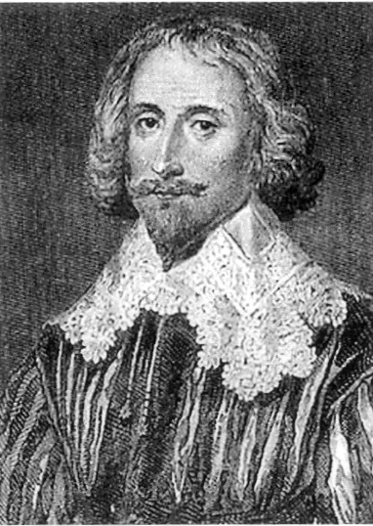
GEORGE SANDYS
Jamestown colony’s Treasurer in Virginia in 1623 and brother of Sir Edwin.
Following the 1622 Algonquian Uprising in Virginia, the English began to establish clustered settlements with communities that were well supplied and defended. Sandys Tenants was an example of this type of post-Uprising, pre-tobacco boom hinterland settlement that transformed the frontier into the beginnings of Colonial America. It was named after the area’s first documented land owner, George Sandys, who served as Jamestown’s inaugural resident treasurer from 1621-25. He was the brother of Sir Edwin Sandys, treasurer of the Virginia Company in London. Sandys sold his four hundred acres in James City to Edward Grendon in the 1620s. When Grendon passed away in 1628, he left the land to his son Thomas, an English merchant. Thomas instructed his attorneys to dispose of the territory, and by 1638 they had arranged a sale with John Browning. Records of the transaction indicated that before Browning acquired the land, John Wareham had been in possession of it, perhaps, initially as a tenant of the Grendons. John Browning’s son, William, repatented his father’s land upon inheriting it in 1646.
By the 1650s or ‘60s, the original Sandys tract had passed into the hands of Colonel Thomas Pettus. Pettus was his Majesties Counselor of State of what was now a Royal Colony. Sandys’ four hundred acres became part of Pettus’ 3,000-acre plantation. The Anheuser-Busch Companies acquired this land in 1969 to develop the 2,900-acre Kingsmill community next to their brewery and their Busch Gardens theme park. Kingsmill was named for Richard Kingsmill, who first settled on this land in 1736.
All three of these Kingsmill riverfront parcels today have permanent homes being built for the first time on this land. Rivers Bluff has two luxury condominium buildings and four more planned, Spencer’s Grant will be starting a fifty-two home development, and River’s Edge has forty-five villas with five more under construction. After almost four hundred years of English land ownership, life “on the edge” is good. So we wish to thank John Smith, Pocahontas, John Rolfe, and Sir Edwin Sandys for providing the human help that got us through the first seventeen years of our nation’s birth.
This four hero view of the 1607 to 1624 Jamestown history of the Virginia Company of London was prepared by John Vaughan, 101 River’s Edge, Williamsburg, VA 23185. It was given to John and Pat’s house guests Roger Preston and Anne Moir of London, England on June 24, 2005. We thank our trusted friend, Rhonda Dunkum, for the typing. Minor updates made April 10, 2006. Aleck Loker added a dozen historical corrections or improvements in April 2007.

