Battle of the Bulge
Major General Hopkins was in charge of building up our World War II Aircraft Production Plants. His primary officer was Dad - - Col. J.C. Vaughan, Jr - - Aero Engineer from NYU.
In comparison with any other history of military or industrial growth, the United States achieved the preeminent position of leading power in the air in an amazingly short time. Personnel in the Army Air Forces grew from 22,000 in 1939 to 2,400,000 in 1944. Only 143 military aircraft were produced in the entire month of January, 1939. Five years later, in January, 1944, twice that many planes were being produced every day! Employment in the industry grew from less than 50,000 wage earners to more than 2 million.
In November and December 1944 Hopkins finally let Dad go to Europe on a special Army Air Corps mission. He and Lt. Col Walter Clark were to parachute behind German lines at a place loaded with German scientists to offer them a chance to come to USA before the Russians forced them to work for Russian missile and jet engine development. One of the last things my Dad told me to do was watch the movie “A Bridge Too Far”. The paratroopers that were supposed to take Dad behind the lines were wiped out at Arnhem Bridge as shown in the movie. The next mission after Arnhem for this unit was supposed to be Dad’s. Total paratrooper losses in British General Montgomery’s plan were 8,000 of the 10,000 who dropped at Arnhem.
Dad still got to go to war, but it was he and Walter in a Jeep with special orders. They drove thru parts of France, Belgium, Luxembourg, Germany, and Holland. They got to some German scientists just before the Russians did. They got lost behind enemy lines twice. They were never wounded. Just the common frostbitten toes and ugly toenails he had the rest of his life.
One of my earliest clear memories as a kid was coming home from school, age 7, and seeing all this army stuff on our kitchen table. I asked mom about it and she said “Oh, some paratrooper landed in the field across the street”. It was Dad returning from Europe.
I recently found these maps my Dad had marked up with his route in two of his old books.
Dad went behind German lines seven times. From North to South, and in chronological order, the places were: At Roer river at Jülich, and at Düren (between Aachen and Cologne and just days before infamous German Ardennes Counteroffensive that started Dec 16, 1944), then Luxembourg, then 2 places just south of Strasbourg, and finally east of Epinal. His route along the Western Front was from Dec 10 thru Dec 22.
On Dec 16, 2004, to mark the 60th anniversary of the surprise German major counteroffensive (along a 50 mile stretch of the Ardennes that Dad had just left), Paul Greenburg wrote this editorial in the Arkansas Democart-Gazette.
Sixty years ago at dawn….
On December 16, 1944, General Bradley came to my headquarters to discuss ways and means of overcoming our acute shortages in infantry replacements. Just as he entered my office, a staff officer came in to report slight penetrations of our lines in the front of General Middleton’s VIII Corps and the right of General Gerow’s V Corps in the Ardennes region…..
-- Dwight Eisenhower,
“Crusade in Europe”
It started with the dawn: an unexpectedly heavy artillery barrage. How had the retreating Germans managed to mass so many guns? Was this just a local attack, or a feint to distract the attention from a major blow elsewhere?
Soon it became clear that the enemy had massed more than artillery. The Sixth Panzer Army, a mobile reserve that had disappeared from the view of Allied intelligence, reappeared. When the barrage lifted, German armor came pouring out of the woods, headed for the seam between the British and American armies.
Instead of sheltering behind the Siegfried Line, the “retreating” Germans were advancing through an only lightly defended 50-mile stretch of the Ardennes.
Allied intelligence had collected reports of a transfer of German troops from the Eastern to the Western front in the fall of 1944, and there was ample evidence that they were being reassembled in the Ardennes, but word never filtered up to headquarters.
The coldest, snowiest winter in European memory made Allied air superiority irrelevant. The Panzers sped on, opening a growing wedge. Allied headquarters was compelled to sacrifice unity of command as the German advance split the British and American armies; Ike had to designate separate commanders for each sector of a crumbling front.
In the heat of battle, confusion reigned. Disguised as American MPs, English-speaking, American-accented Germans were sending relief convoys down the wrong roads, or into murderous ambushes. Just liberated French cities were exposed again, and Paris was jittery. The British press demanded that Eisenhower turn command of the land forces over to Montgomery – or anyone else competent.
Van Runstedt and his staff had taken everything into account except the sheer cussedness of the American resistance. The 7th Armored held onto the crossroads at St. Vith longer than anyone would have imagined possible. And at Bastogne, the key to the battle, the 101st Airborne refused to yield at all, and entered legend.
According to the German battle plan, Bastogne was to be overrun on the second day of the operation; it never was. Gen. Anthony McAuliffe’s one-word response to the German commander’s surrender terms would become a classic summation of American defiance: “Nuts!”
Forced to split up and go around isolated pockets of American resistance, the German advance slowed. Unlike 1940, there was no breakout. Methodically, the Allied command drew up new defensive lines, and then held. And to the South, Patton was turning the whole Third Army on a dime and hurtling to the rescue. . . .
Before it was over, the Battle of the Bulge would involve three German armies, the equivalent of 29 divisions; three American armies, or 31 divisions; and three British divisions augmented by Belgian, Canadian and French troops.
The Germans would lose an estimated 100,000 irreplaceable troops, counting their killed, wounded and captured; the Americans would suffer some 80,000 casualties, including 19,000 killed – that’s a rate of 500 a day – and 23,554 captured.
There’s a different kind of war on now, but war itself remains the same brutal experience. And it invokes the same admixture of fear and desperation, bloody miscalculation and incredible heroism, over-confidence and unchanging defeatism.
Much was gained by that decisive victory in the Ardennes 60 years ago, but victory obscures as much as it reveals. How the Battle of the Bulge turned out may seem inevitable now that history has unfolded but, as Wellington was supposed to have said of Waterloo, “it was a damned close-run thing.”
The passage of time erodes memory, and we tend to forget the pain, the sacrifices, the mercurial swings of public opinion, the alternating hopes and fears, the daily uncertainty of war . . . and the necessity of endurance.

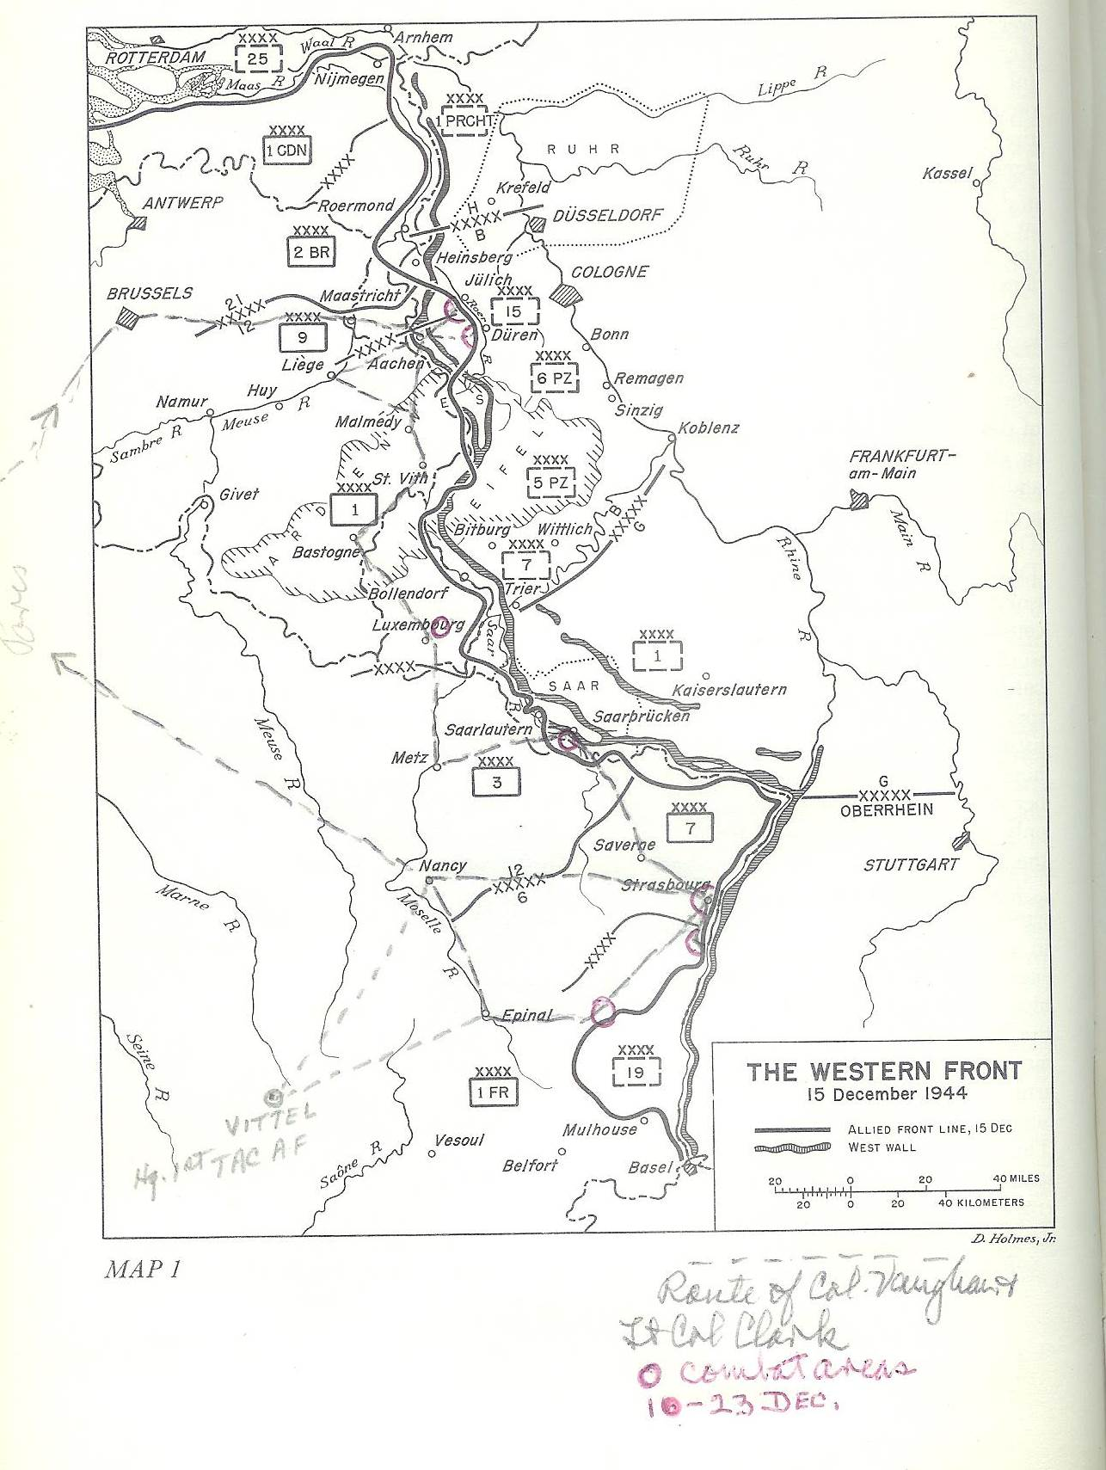

Reference: The Western Front map is from the book – U.S. Army in World War II, The European of Operations, The Ardennes: Battle of the Bulge by Hugh M. Cole, Office of the Chief of Military History, Dept of the Army, Washington, D.C., 1965.
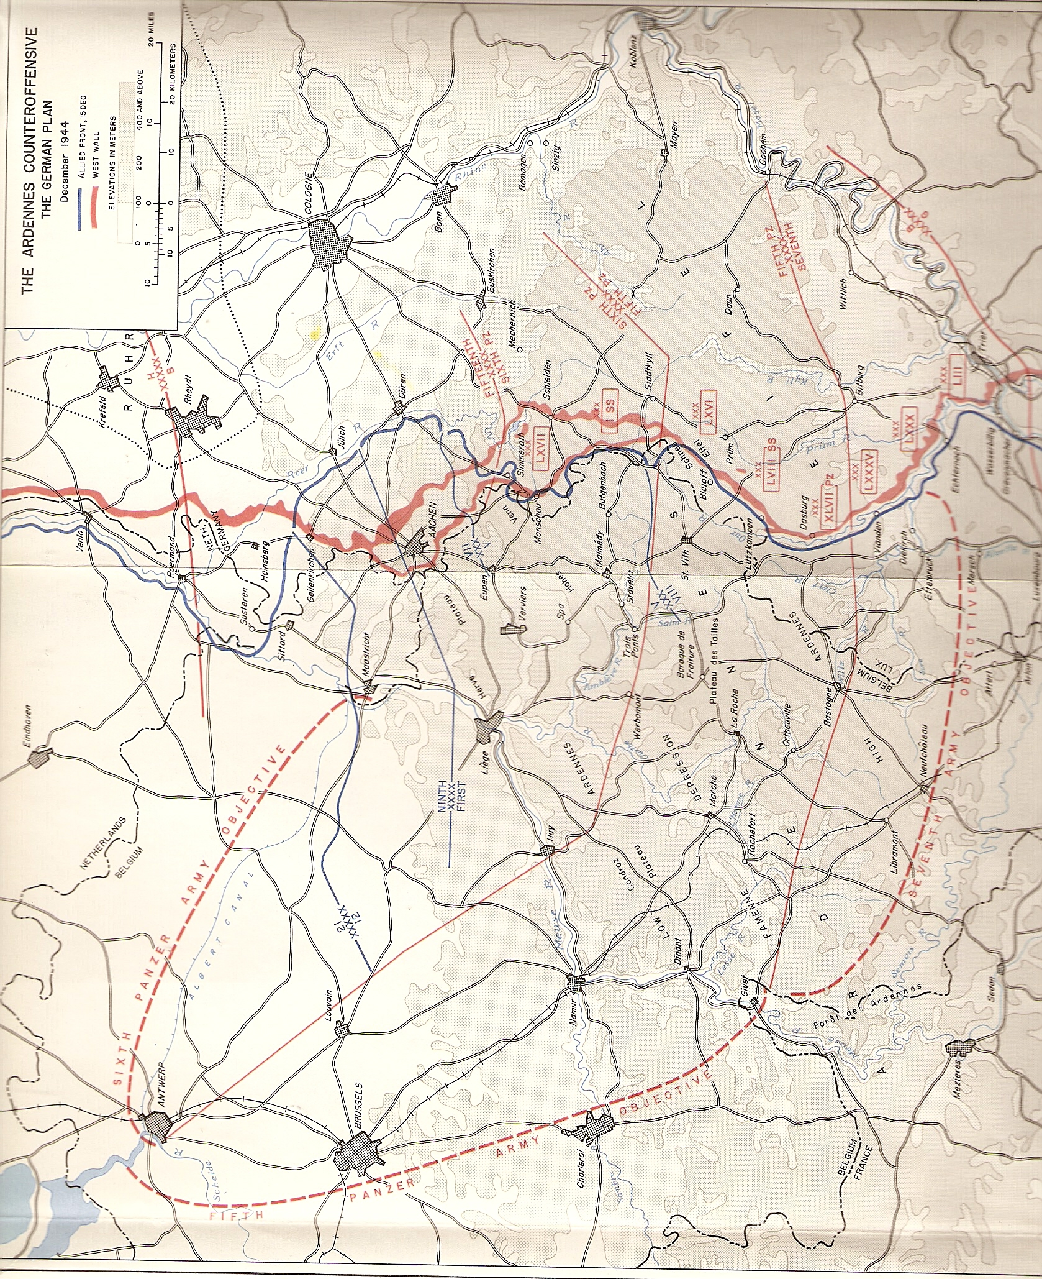
Reference: The Ardennes Counteroffensive map is from the book – U.S. Army in World War II, The European of Operations, The Ardennes: Battle of the Bulge by Hugh M. Cole, Office of the Chief of Military History, Dept of the Army, Washington, D.C., 1965.

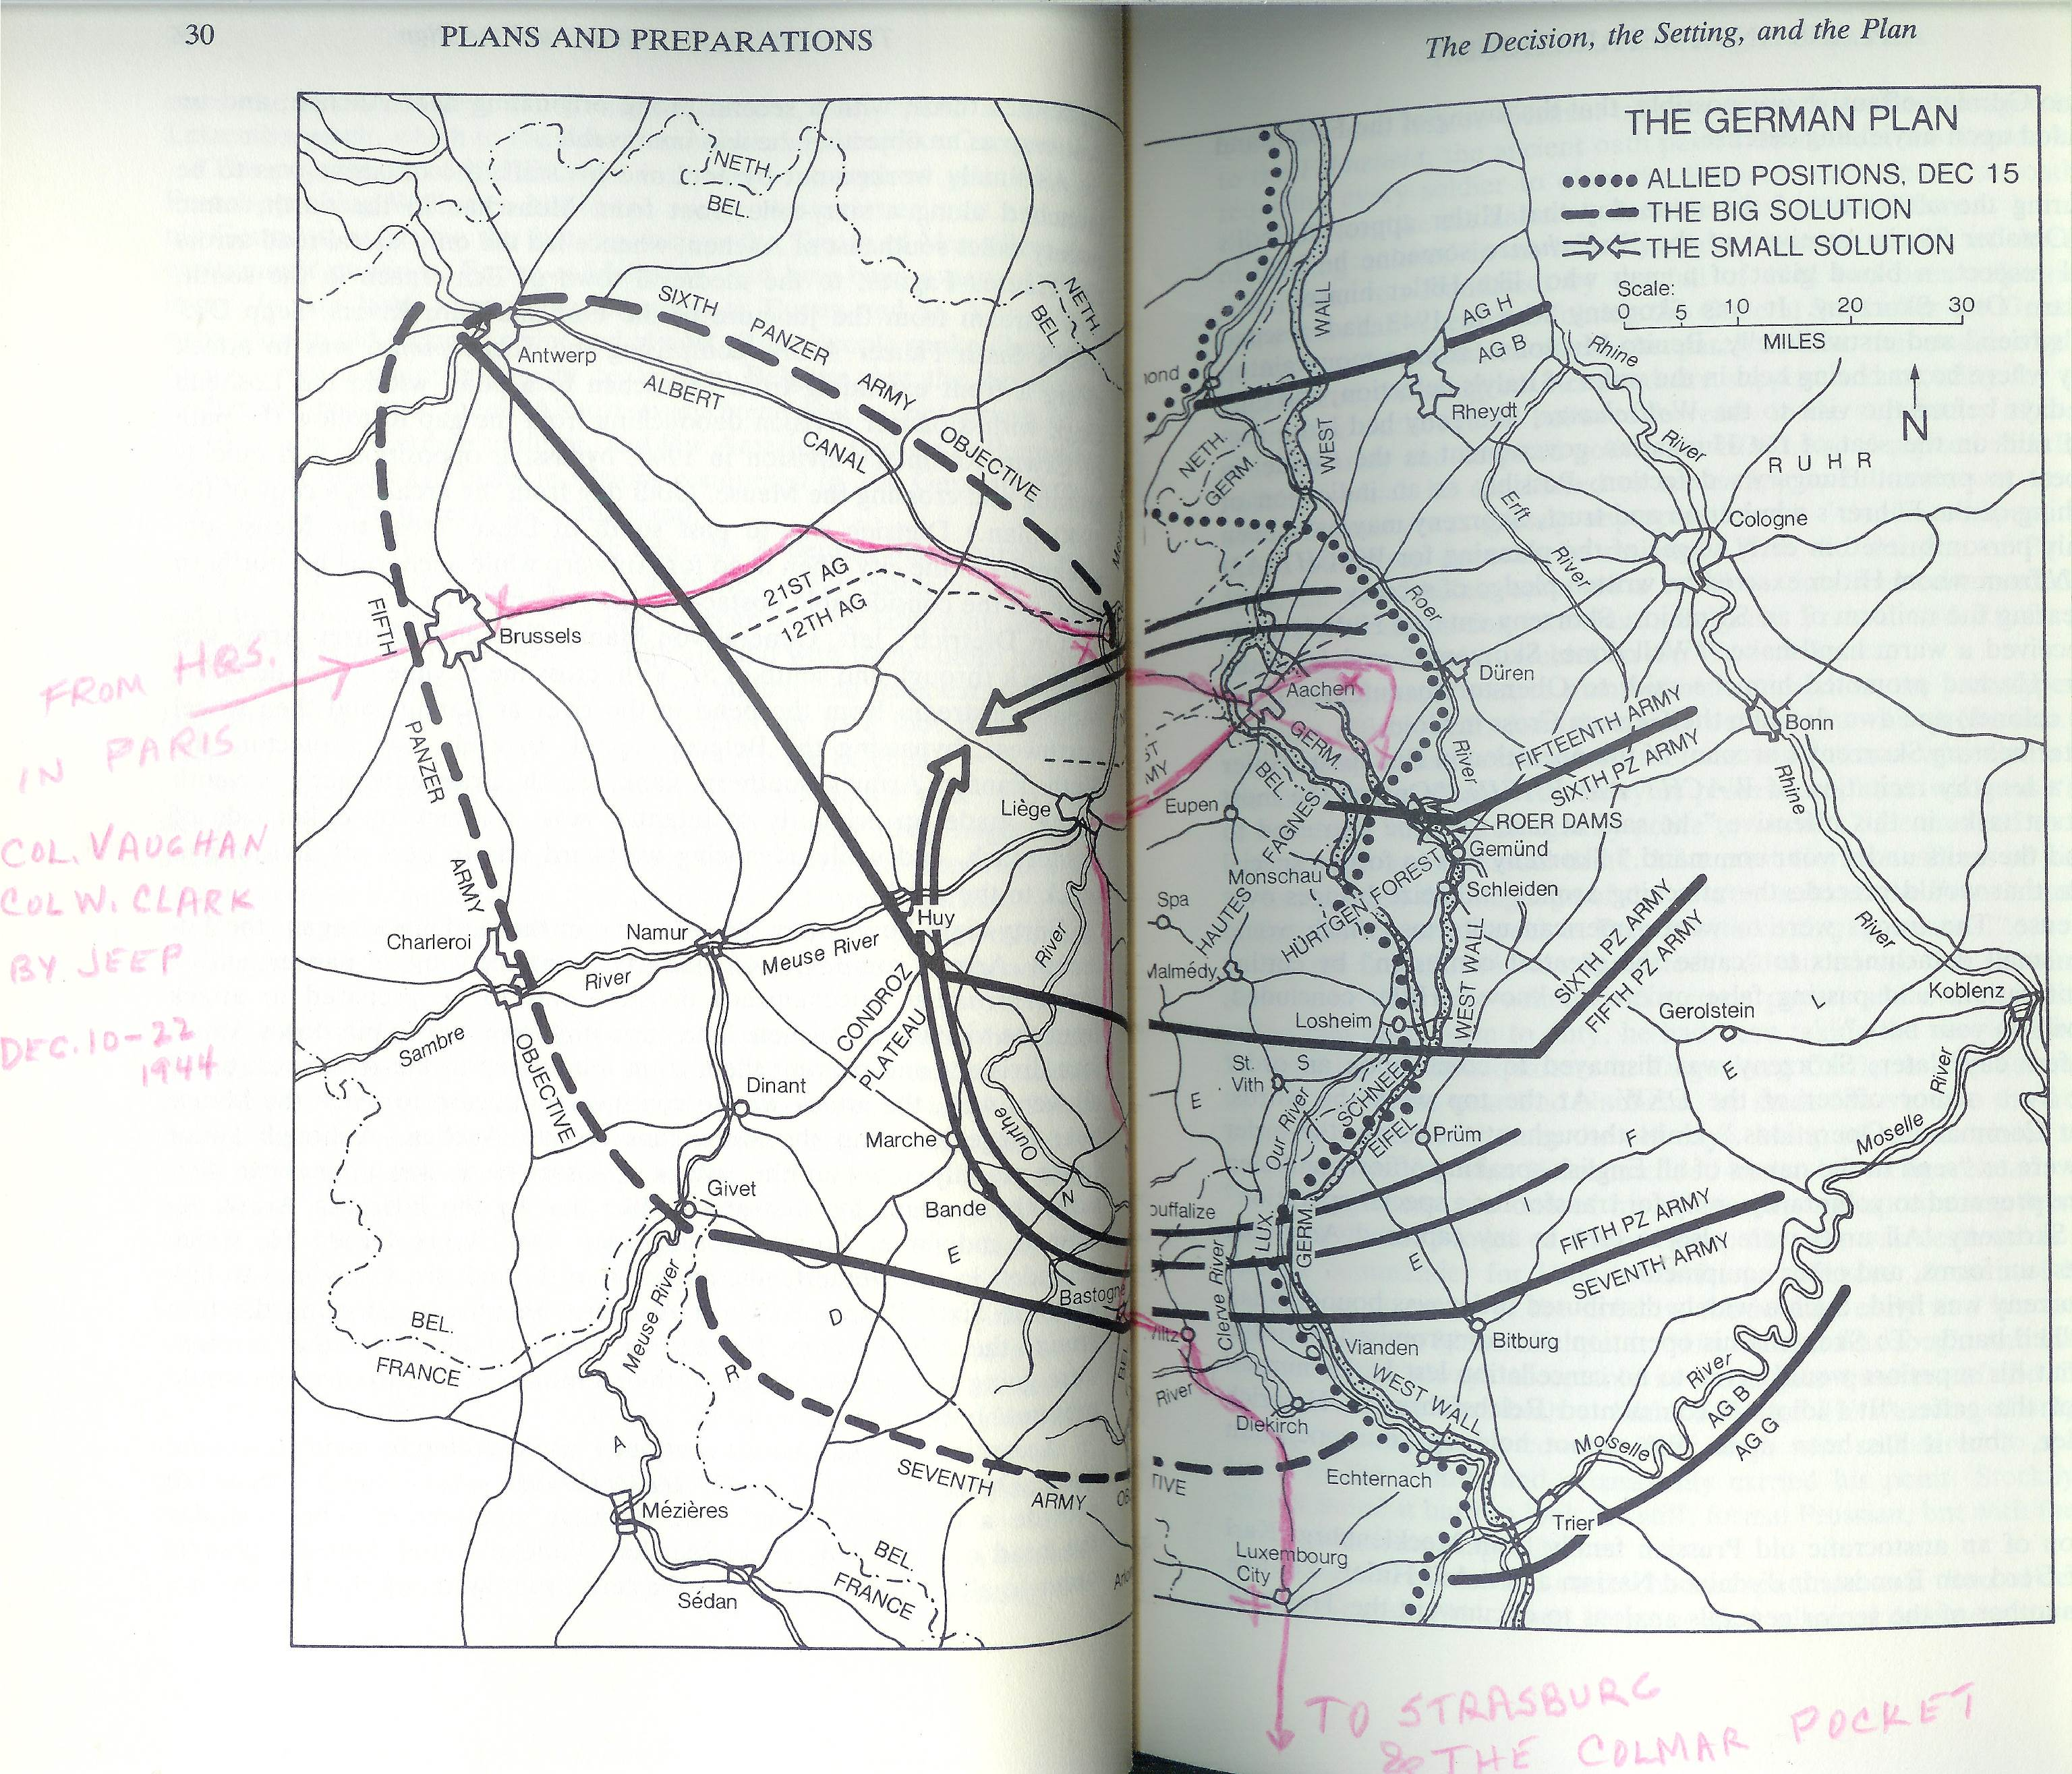

Reference: A Time for Trumpets - - The Untold Story of Battle of the Bulge by Charles B. MacDonald, 1985
Dad wrote in the front of his copy of the book, A Time for Trumpets- - The untold story of the battle of the bulge:
“A very close call!!! But I was lucky!”
Dad read a lot. As a kid he read an entire set of encyclopedia books cover to cover – subjects alphabetical. He had a talent I lack - - He remembered everything.
Dad was a happy, fun-loving person. He and Mom and their friends had many laughs. He was loyal. He had practical, common sense. My friends loved my folks because my folks were always sincerely interested in them. Dad didn’t go to church but he practiced Christian principles with everyone. He always signed his letters:
As ever, Clark

