**How it all happened for me.** By John Clark Vaughan, 111 August 4, 2024

In hindsight**, three Christmas times were what brought Pat Mareydt and I together**. **Christmas #1 (1957)** was our first meeting, I was 20 and she just turned 17. My friend Gary brought her by my parents’ home in Annandale, VA. Pat was a senior in high school and I was a junior at Virginia Tech. Gary was dating Pat but since he would be off to Europe to be with his folks for Christmas holidays, typical Gary told me: “she will be dating others while I am gone so she might as well be dating my friends”.

Christmas was a special time for Pat. She was born December 24th, and learned to promote to not forget her – this is double time for her! She was good at that promotion and also truly loved the season.

Pat and I had a nice time that Christmas #1. On our first date I picked her up from a Department Store where she was working and we went on a double date with Jim Gaines. Second date I picked her up at her parents’ house and got to meet her charming mother and her intimidating father. “Your dad wants you home by 11”- I had her back home at 10:45. That was about it for 2 years. She finished High School and went off to Univ. of Michigan. I was off to Dover AFB as an aircraft flightline maintenance officer.

Two years later we met again, **Christmas #2 (1959).** I was 22 and she just turned 19. We both returned to the D.C. area to see our folks for the holidays. I came in from Dover Air Force Base as a new 2nd Lt, and Pat came in from University of Michigan where she was a sophomore living in the Chi Omega Sorority house. She came to a Christmas party I had. She never saved any of my letters to her, but I still have 30 that she wrote to me. The first was written 5Jan60 after she returned to college from Christmas #2. The other 29 were written in a 7 month period in 1963. Here is that first letter:

++++++++++++++++++++++++++++++++++++++++++++++++++++++++++++++++++++++++++++++++++

Dear John, January 5, 1960

Didn’t expect to get a letter so soon, did you? Well, right now I am on telephone duty and have to answer the phone for two hours so I thought I would catch up on some of my letter writing. Besides when you write mail you get some, don’t you?

School is the same old drag with lectures and microscopes, sleepless nights and tired bodies. I can really think of more pleasant things to do, but I guess I have never had it so good; and probably never will.

Many girls came back pinned or engaged, and all the rest of us really feel bad, because we have nothing but bags and blue circles to show for our vacations. In fact we took a count and half the house is attached in some way or another. In fact the girl next door to me is married! It’s really rather depressing. Wouldn’t you like to get married when you’re a 1st Lt.? After all it is leap year, dear?

John, I wanted to tell you sincerely that the party you gave was really nice. I know I enjoyed myself immensely, and I’m sure that everyone else did also. It was lovely – now I’m serious.

Say if you are ever home for a weekend and one of the fellows needs a date – not Gary or Howard cause they don’t get along with her – I know a great girl. Lane Medford Ja.40044 She works in Wash. & is really neat, so just in case. I’m not pushing her or anything, but I thought you might want to add another to your list of “group availables”. She’s 5’4’’ – good looking & swings.

Behave yourself now and let me know when the big date will be. As always, Patt

++++++++++++++++++++++++++++++++++++++++++++++++++++++++++++++++++++++++++++++++

Then we met again, 3 years later, during **Christmas #3 (1962).** I had no idea I was getting married in 9 months – or to who! I had just started a 24 month program at Air Force Institute of Technology (AFIT) in Dayton, Ohio to get a Master’s degree in Astronautics. Class GA-64 was great, 2 years with same 20 officers in same classroom. I came home between quarters to see my folks in Annandale, VA. Six months and two AFIT breaks later, we had our marriage date set in 3 more months!

**AFIT Break #1** **– December 1962**. Gary told me: “Guess who is back in town? Pat Mareydt, she is teaching school and hanging out with Lane Medford”. I thought, great, just call and whoever answers the phone ask them out. Lane was fun and a great dancer, and Pat, well, she was on the A List for someone I might even consider marrying someday.

Our “first real date” after about 3 years of not communicating was closing a Georgetown bar at 2 am singing Christmas carols with Gary, Howard and their dates. She didn’t tell me she was flying out early the next morning to return her engagement ring. She told me much later that on final approach she looked in mirror and saw that each ear had a different earing. **Again, we had a great time over Christmas**. **It seems I was** **starting to fall in love, for the first time**. Then I went back to AFIT in Ohio.

At this point in time, Pat’s letter writing seriously started – Jan 16 & 25; **Feb 7; Mar 5** & 24; Apr 3,7,16, & 22; May 6,11,16,22,24, & 27; Jun 1, 19, 21, 24, 25, & 26; Jul 22 & 29; Aug 8, 9, 11, 13 & 18. We were together from Aug 23, 1963 for 59 years. We rarely called, too expensive. So I have the words today in the letters.

**AFIT Break #2 started March 15th**. The Feb 7, 1963 Valentine’s Card is shown above and came with the attached letter. The other attached letter was March 5, 1963 just before I returned for Spring break to see my parents. We actually didn’t stay in DC area for long for that break; we headed up to a Delaware beach for a few days. I set my Ohio roommate up with Pat’s friend, but that match was a disaster – but Pat and I again had a great time! Then back to Ohio until June, but plenty of letters were coming.

**AFIT Break #3 – June 1963**. Back to D.C. to see Pat (oh yes, also my folks). One night, parked out in front of Shoreham Hotel about to go in and see the comedian Mark Russell (Up the Potomac without a paddle), I tried to propose to Pat. I had never done anything like that before, and I wasn’t very good. I opened with “The chemistry is right”, but then got into describing chemistry. She finally interrupted, saying she couldn’t follow what I was saying at all, and said “let’s go in to get a good seat”.

June 16 was in a few days, the date she had to sign a contract that she would teach school in Arlington, VA the next school year – or would she be living in Ohio? Big decision. So she put it up to me late on June 15th to decide. Early on 16th she called my folks house, my mom said I was asleep, Pat said “wake him up”. I came to phone and she said “well?” I said I had been thinking all night and I couldn’t think of any disadvantages. She said great, she then told the school. I told my folks they were not losing a son; they were gaining a daughter in law. September 7 had to be the date, because AFIT Fall quarter started 9 days later. I don’t think we were ever “engaged”.

Pat wanted to have a small wedding. Her folks were in Japan and were returning to a DC August 1st. Pat was going to wait to tell her mom, but my mom insisted Pat immediately tell her folks, which she did, and we had a bigger wedding. Her dad asked who Pat was going to marry, and she said the guy with the Oldsmobile convertible, and he remembered the car (and me), and said good. He liked me, but being an intelligence officer of the highest level, he immediately ran a background check on me, Gary, Howard, and Jim. He told me how Howard had flunked.

**AFIT Break #4.** **We were married on September 7, 1963**. Looking back 61 years, nothing better ever happened to me. I thought Pat would be bored in Dayton while I was so involved in an intense school, so without telling her, before our wedding, I put on my uniform and went to Fairborn, Ohio school system and got her a job. They said they didn’t have any teachers from University of Michigan and would be happy to have her. I told Pat: “I have good news and bad news – - I got you a job! - but we have to cut our honeymoon short at Tides Inn because you have to start at school”. She didn’t see any good news.

Here are the two letters. Pat was working it, and sassy. That’s two of the unlimited things that made her so attractive. She had strong values and a wonderful spirit. I love her forever, and that’s a long time..

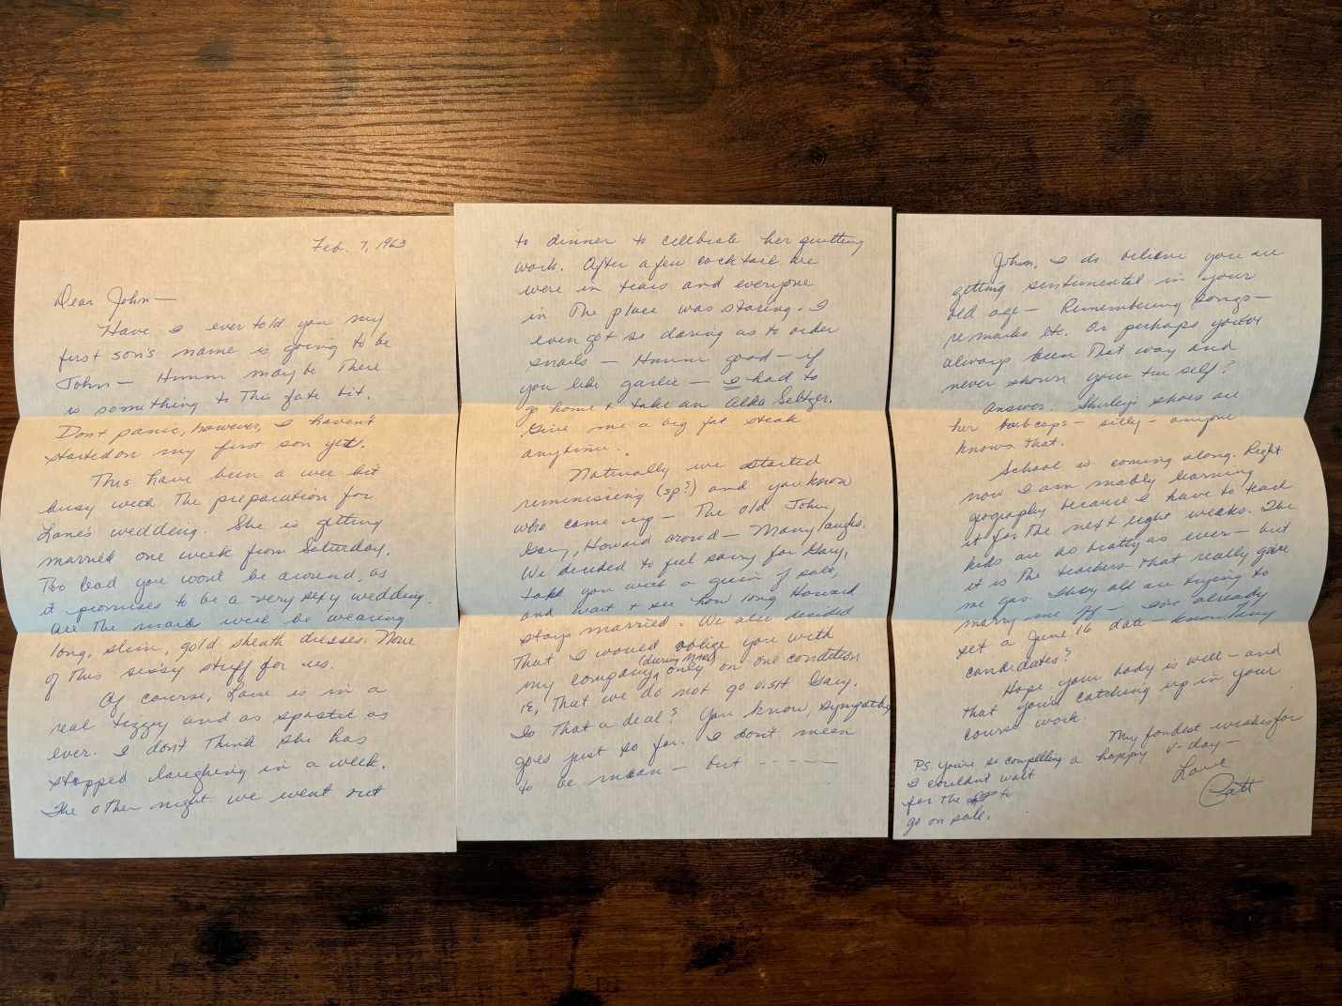

Dear John – Feb. 7, 1963

Have I ever told you my first son’s name is going to be John – Hmmm maybe there is something to this fate bit. Don’t panic, however, I haven’t started on my first son yet.

This has been a wee bit busy with the preparation for Lane’s wedding. She is getting married one week from Saturday. Too bad you won’t be around, as it promises to be a very sexy wedding. All the maids will be wearing long, slim, gold sheath dresses. None of this sissy stuff for us.

Of course Lane is in a real tizzy and as spastic as ever. I don’t think she has stopped laughing in a week. The other night we went out to dinner to celebrate her quitting work. After a few cocktails we were in tears and everyone in the place was staring. I even got so daring as to order snails – Hmmm good – if you like garlic – I had to go home and take an Alka Seltzer. Give me a big fat steak anytime.

Naturally we started reminiscing and you know who came up – the old John, Gary, Howard crowd - many laughs. We decided to feel sorry for Gary, take you with a grain of salt, and want to see how long Howard stays married. We also decided I would oblige you with my company (during March) only on one condition i.e., that we do not go visit Gary. Is that a deal? You know, sympathy goes just so far. I don’t mean to be mean – but …..

John, I do believe you are getting sentimental in your old age – remembering songs – remarks etc. Or perhaps you have always been that way and never shown your true self?

Answer: Shirley’s shoes are her hubcaps – silly – anyone knows that.

School is coming along. Right now I am learning geography because I have to teach it for the next eight weeks. The kids are as bratty as ever – but it is the teachers that really give me gas. They all are trying to marry me off – I’ve already set a June 16 date – know of any candidates?

Hope that your body is well – and you are catching up on your course work.

My fondest wishes for a happy V-day – Love Patt

PS. You are so compelling I couldn’t wait for the cards to go on sale.

Dear John – March 5, 1963

I am just knocking one letter off after another to all my many friends male and female. Thus, I am printing these first few lines just for a change in pace.

Now back to the scribble – much better. At the present I am anxiously awaiting your arrival. Only ten more days – I can hardly wait. It has been so long.

Yes, John, I am very serious about this Gary business. I don’t mind seeing him, but one hour is maximum. I don’t know what he told you about why I am not fond of him, but I am sure he was on the wrong track. I think he thinks he sort of dumped me on you when he went to Morocco that Christmas - & that I resented it. Hardly – It was what I had waited for – for so long.

You see, Gary was very fine and fascinating while I was a senior in high school – good dancer, charming, handsome, man of the world etc., but since then I’ve grown up just a wee bit, and I don’t think he has. Gary is very much an egoist & much too wrapped up in Gary & his problems. Also I cannot bear pseudo-intellectual with a lot of philosophy to “discuss”. So much of it is hog-wash and in my many years of experience I have grown to dislike this type of person. Dosteoevsky (I can’t even spell it) at two in the morning leaves me cold. One more thing – women do not like to be told how women are & how they think and act. To sum everything up – Gary bores me, insults my intelligence, and for those reasons I dislike him. How is that for a concise resume of the situation. Enough!

As for you, Lt Vaughan, you excite me, fascinate me, make my very soul tremble! Now if I didn’t take all that with a grain of salt, I would be a physical, sexual, and mental wreck!

Things haven’t been too exciting without you around. Last weekend I went to my sisters in N.J. (she’s now moved). It was relaxing and enjoyable. Contrary to my former opinion this family life interests me (that is except for the cooking, cleaning, washing & babies) – How about you? By the way – just when will you become a Captain?!?!

I am sorry to disappoint you, but Lane was a perfect bride – no misbehavior. I have seen her since & everything is rosy – cooking & all.

(If you turn down this flap, you will immediately know who this is from. No suspense of waiting until the end.)

School has been the usual – the only excitement is that the colored kids are beating up the white kids. Riots!

I am looking forward to seeing you Mar. 15 & will be waiting anxiously for your call – Please don’t wait till 10 pm if you get in earlier – I couldn’t stand the suspense. I usually get home around 4pm.

Love, Patt

P.S. This sheet is longer because my stationary got mixed up & in the heat of passion I didn’t notice.