3 A.  [Thoughts After the 2012 Election](https://www.pvbv.com/wp-content/uploads/go-x/u/1cff37a2-a58f-457e-95cb-419716c38c8a/Thoughts-After-the-Election.doc)

The number one threat to the liberty and social mobility of people throughout the world is government, and it usually (but not always) is from their **own**government.  
  
3B.  [Thoughts Before the 2024 Election](https://www.pvbv.com/wp-content/uploads/go-x/u/43a257f9-effe-4a83-bc04-ca375b0752b3/Debt-21Jun2024.docx)

March 21, 2024 *The interest rates on your credit cards, student loans, and even your mortgage are all up now because of the Treasury’s borrowing spree. It’s costing you thousands.* [EJ Antoni](https://www.dailysignal.com/author/e-j-antoni/)/ [@RealEJAntoni](http://twitter.com/RealEJAntoni)

April 2, 2024 The United States is almost certainly on an unsustainable path with regard to the astronomic rise in its national debt, according to a million simulations run by Bloomberg. By [**Megan Henney**](https://www.foxbusiness.com/person/h/megan-henney) **[FOXBusiness](https://www.foxbusiness.com/)**.

June 21, 2024 After growing for decades, this year the U.S. debt will roughly match its GDP. Throughout history, nations that blithely piled up their obligations have eventually met unhappy ends. [Gerald F. Seib](https://www.wsj.com/news/author/gerald-f-seib)

July 29, 2024America’s Debt Hits $35 Trillion. [David Ditch](https://www.dailysignal.com/author/david-ditch/)

*A billboard displays the national debt at a bus stop in Washington, D.C., on Feb. 8, 2022. In the past two-and-a-half years alone, it has risen an additional $5 trillion. (Jemal Countess/Getty Images)*

$35 trillion amounts to about $267,000 for every household in the country. During fiscal year 2023, ending Sept. 30, 2023, the federal government raked in more than $4.4 trillion in revenue—or more than $13,500 for every man, woman, and child in the country. That was more than enough to fund core governmental functions. However, unending bureaucratic bloat and out-of-control entitlement programs led to $6.1 trillion in spending—more than $18,000 per person.

Even if America avoids a recession or a major war, the deficit is on pace to approach $3 trillion per year by 2034. It wasn’t long ago that a [$1 trillion](https://www.dailysignal.com/2019/09/16/trillion-dollar-deficits-dont-make-america-great/) deficit was worrisome.

In calendar year 2021, the most recent year for which there is complete data, the top 1% of households paid 46% of income taxes. In contrast, the bottom 95% of households paid a combined 31% of income taxes. **The bottom 50% of households (making less than $48,700/year) earned 10% of the income and paid only 2% of all income taxes.**

America’s federal tax system is far more progressive than most other developed nations. What separates the U.S. and Europe is the [punishingly high taxes](https://www.dailysignal.com/2023/05/23/european-level-taxes-coming-america-us-keeps-unsustainable-spending/) that European states impose on lower- and middle-class families. Rather than throwing more hard-earned money into the gaping maw of the federal behemoth, policymakers should focus on reducing spending.

The $35 trillion national debt is a grim milestone, but there’s still time to avoid **the greatest** **bankruptcy in human history** if the nation’s leaders are willing to stand up to special interests.

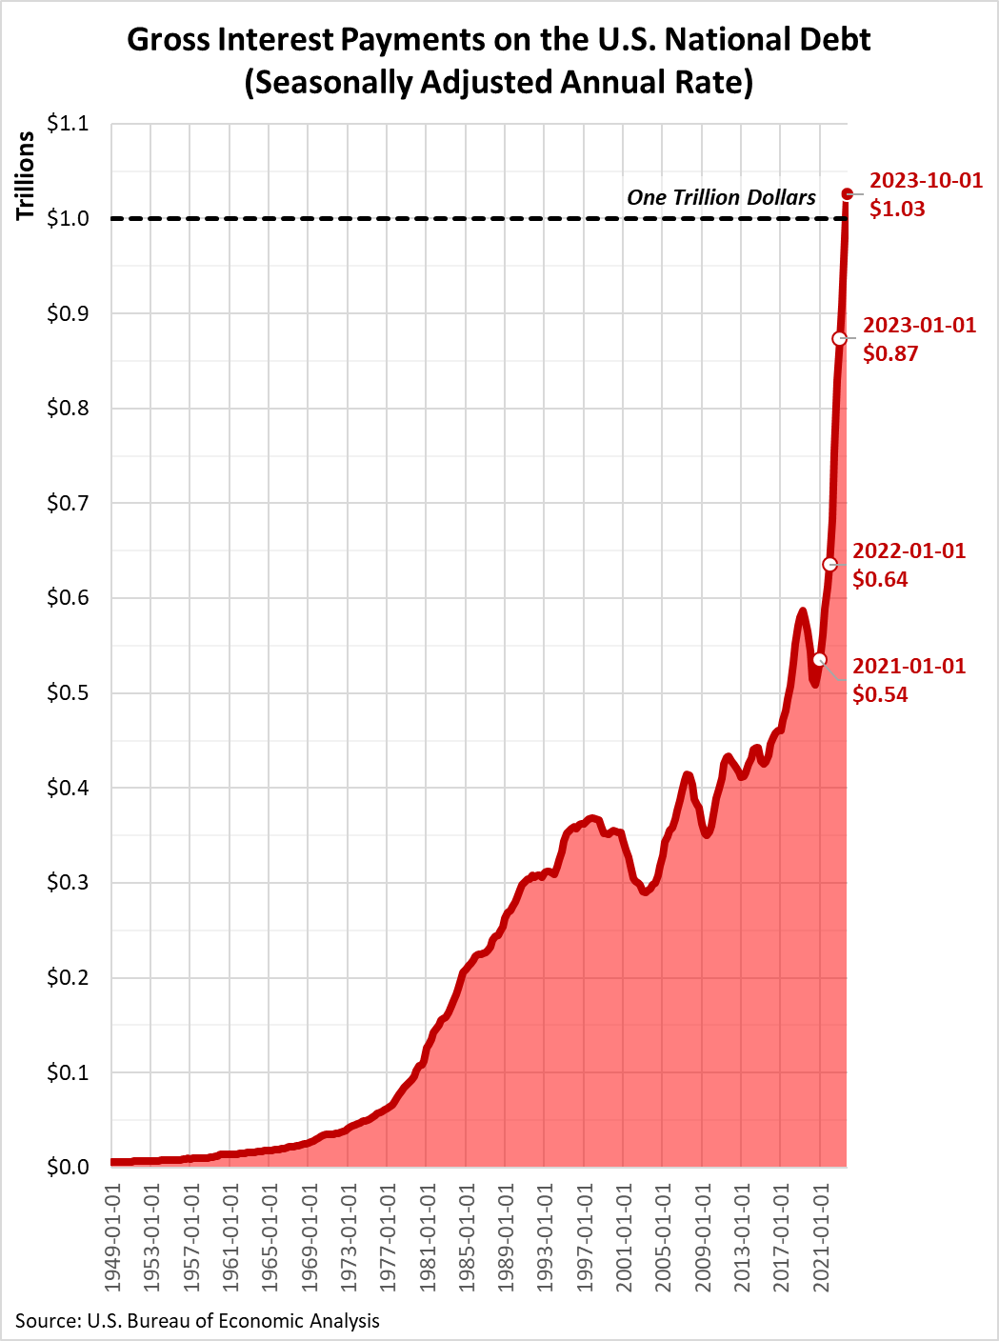

The “Please help my friend Sam” numbers shown below in item 7 need a major update on the debt item. Since those numbers were generated, our yearly payment to cover our runaway debt expansion has exploded from the $251 billion/year to todays about $1 trillion/year!  Have we screwed ourselves?! Are we aware of what we have been doing!?